# Intent Detection Using Natural Language Understanding

A Project Report Submitted in the partial fulfilment of the requirements for the award of the degree of

# Bachelor of Technology in

**Department of Computer Science and Engineering**

**by**

**P. Franklin Joseph**

**180030767**

### G. Keerthi 180031083

Under the Supervision of

### Dr. C Karthikeyan



**KONERU LAKSHMAIAH EDUCATION FOUNDATION,**

**Green Fields, Vaddeswaram- 522502, Guntur(Dist), Andhra Pradesh, India.**

**November – 2021**

#### KONERU LAKSHMAIAH EDUCATION FOUNDATION DEPARTMENT OFCOMPUTER SCIENCE AND ENGINEERING



***DECLARATION***

# The project report entitled “Intent Detection Using Natural Language Understanding” is a record of bonafide work of “P Franklin Joseph(180030767), G. Keerthi(180031083)”, submitted in partial fulfilment of the requirement for the award of degree in BACHELOR OF TECHNOLOGY in COMPUTER SCIENCE ENGINEERING to the KL University .

The results embodied in this report have not been copied from any other departments/University/Institute.

|  |  |
| --- | --- |
| **Name of the Student** | **Univ. Reg. No** |
| **P Franklin Joseph** | **180030767** |
| **G Keerthi** | **180031083** |

#### KONERU LAKSHMAIAH EDUCATION FOUNDATION DEPARTMENT OFCOMPUTER SCIENCE AND ENGINEERING



***CERTIFICATE***

This is to certify that this term project report entitled **“Intent Detection Using Natural Language Understanding”** is being submitted by “**P Franklin Joseph(180030767), G Keerthi(180031083)”** submitted in partial fulfilment for the award of degree in **BACHELOR OF TECHNOLOGY** in **COMPUTER SCIENCE ENGINEERING** to the **KL University** is a record of bonafide work carried out under our guidance and supervision.

The results embodied in this report have not been copied from any other departments/ University/Institute..

#### Dr. C Karthikeyan Dr. V. HARI KIRAN Guide Head of the Department

**A Signature of the EXTERNAL EXAMINER**

### Abstract

Natural language understanding (NLU) is the process through which organized semantic forms are converted into sentences. The scarcity of annotated training data remains a major barrier for NLU. Previous semi-supervised learning-based research have mostly focused on exploiting unlabeled phrases to overcome this data sparsity challenge. We describe the dual goal of NLU, semantic-to-sentence generation (SSG), and provide a novel framework for semi-supervised NLU with the associated dual model in this paper. The framework comprises of dual pseudo-labeling and dual learning approaches, allowing an NLU model to fully use the data (labelled and unlabeled) via a closed-loop of the primal and dual tasks. The approach may utilize pure semantic forms as well as unlabeled phrases by including the dual-task, and iteratively enhance the NLU and SSG models in the closed-loop. The proposed methods are then tested on two publicly available datasets (ATIS and SNIPS).

Experiments in a semi-supervised scenario reveal that our techniques greatly outperform various baselines, and thorough ablation experiments are carried out to prove the framework's efficiency. Finally, in the supervised environment, our technique can attain state-of-the-art performance on the two datasets.

**Chapter 1** **INTRODUCTION**

* 1. **Objective**

As a consequence of the expansion of mobile internet and smart gadgets, conversational dialogue systems such as Amazon Alexa, Google Assistant, Apple Siri, and Microsoft Cortana have lately gained in popularity. Natural language understanding (NLU) is a key component of these systems, converting user utterances into appropriate semantic representations for a certain domain (e.g., booking hotels, searching flights). The primary purpose of the NLU module in goal-oriented conversation systems is frequently comprised of two sub-tasks: intent detection and slot filling. In most situations, intent detection is seen as a sentence classification problem, whereas slot filling is regarded as a sequence labelling problem in which contiguous sequences of words are tagged with semantic labels (slots).

### Problem Statement

Deep learning has outperformed most standard techniques in the field of supervised learning for intent detection and slot filling in NLU. The deep learning approach, on the other hand, is known for requiring vast amounts of labelled data, which limits the scalability of NLU models to new domains owing to the annotation cost. To address the data sparsity issue in NLU, semi-supervised learning approaches are used, which employ a large number of unannotated phrases to supplement supervised NLU training. Unlabeled phrases are used by semi-supervised learning algorithms to enhance input encoders or create more samples with projected pseudo-labels. In addition to pure sentences, pure semantic forms (i.e., intents and slots without sentence expressions) can be employed in semi-supervised NLU (i.e., unannotated sentences).

Semantic forms may be more cost-effective and efficient than collecting in-domain statements since they are well-structured and may be automatically produced or synthesized using domain knowledge. Earlier semi-supervised NLU algorithms, however, were unable to exploit pure semantic forms data.

### Objectives

* + - To generate sentences based on structured semantic forms, a dual model for joint intent detection and slot filling in NLU is developed.
    - Using the dual model, we present a novel framework for semi-supervised NLU that can better utilize unlabeled data.
    - We illustrate the effectiveness of our proposed semi-supervised NLU architecture using thorough experiments on the ATIS and SNIPS datasets. When supervised, it likewise produces state-of-the-art results.

### Need for present study

* + - Deep learning is known for requiring large amounts of labelled data, which limits the scalability of NLU models to new domains due to the high cost of annotation.
    - To address the data sparsity problem of NLU, which employs numerous unannotated sentences to improve supervised NLU training, semi-supervised learning algorithms are applied, which focus on exploiting unlabeled phrases to strengthen input encoders or provide additional samples with anticipated pseudo-labels.
    - As shown in Fig. 1, we introduce the twin tasks of intent detection and slot filling in NLU in this paper

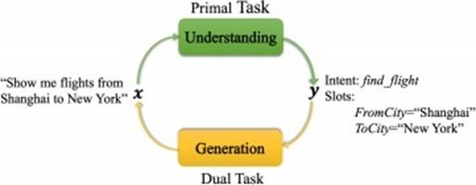

Figure 1 depicts the NLU and its dual role. NLU performs the most fundamental function, converting an input phrase into the intent and slots that correspond to it. In the other way, semantic-to-sentence generation (SSG) transforms the goal and slots into a plain English sentence.

* + - By including the dual goal, a novel semi-supervised NLU framework is provided that can use both pure phrases and pure semantic forms (i.e., intents and slots).
    - A dual pseudo-labeling approach and a dual learning algorithm are the two parts of this system.
    - In the dual pseudo-labeling strategy, a dual model is used to generate pseudo sentences for pure semantic forms, while a primal model is utilized to generate pseudo labels for unlabeled sentences.
    - We next use these pseudo-labeled instances and the labelled dataset to repeatedly retrain both the primal and dual models.
    - Furthermore, both the primal and dual models are trained using the dual learning approach in a closed loop. New validity incentives are offered to assess plausible phrases and semantic structures.

## Chapter-2 LITERATURE REVIEW

**P. Xu and R. Sakariya,** proposed a convolutional neural network-based joint model for intent detection and slot filling (CNN). The suggested architecture may be thought of as a neural network (NN) variant of the triangular CRF model (TriCRF), in which the intent label and slot sequence are represented together and their dependencies are taken advantage of. In contrast to left-to-right models in current NN-based slot taggers, our slot filling component is a globally normalized CRF type model. Its characteristics are retrieved automatically by CNN layers and shared by the intent model. We show that our slot model component produces state-of-the-art results, greatly outperforming CRF. In both intent and slot, our joint model surpasses the conventional TriCRF by 1% absolute. Our combination model provides 0.7-1 percent and 0.9-2.1 percent absolute benefits over the separate modelling strategy for intent and slot, respectively, on a variety of different domains.

For intent identification, a variety of common classifiers, including logistic regression and support vector machines, can be employed. Conditional random

field (CRF) is a tried-and-true approach for slot filling that has seen a lot of application.

CRF directly models the global conditional distribution, as opposed

to left-to-right, factorized probabilistic models for sequence labelling like maximal entropy Markov models (MEMM), and is frequently assumed to avoid the label

bias problem that locally normalized models face.

**Bing Liu and Ian Lane,** Such attentions provide additional information to the intent classification and slot label prediction. Machine translation and speech recognition have lately showed promising results using attention-based encoder- decoder neural network models. We present an attention-based neural network model for combined intent recognition and slot filling, which are both key processes in many speech comprehension and dialogue systems, in this paper. In contrast to machine translation and speech recognition, slot filling requires intentional alignment. We investigate several approaches to adding alignment information into the encoder-decoder system. We suggest bringing attention to alignment-based RNN models, based on the attention mechanism in encoder-

decoder models. On the benchmark ATIS task, our independent task models achieve state-of-the-art intent detection error rate and slot filling F1 score. Over the standalone task models, our hybrid training model achieves 0.56 percent absolute (23.8 percent relative) error reduction on intent detection and 0.23 percent absolute gain on slot filling.

**Chih-Wen Goo, Guang Gao, Yun-Kai Hsu, Chih-Li Huo, Tsung-Chieh Chen, Keng-Wei Hsu, Yun-Nung Chen,** For combined intent detection and slot filling, attention-based recurrent neural network models with separate attention weights have reached state-of-the-art performance. Given the strong association between slot and intent, this study offers a slot gate that focuses on understanding the relationship between intent and slot attention vectors in order to improve semantic frame outcomes through global optimization. On the benchmark ATIS and Snips datasets, the studies reveal that our proposed model increases sentence-level semantic frame accuracy by 4.2 percent and 1.9 percent, respectively, when compared to the attentional model.

In spoken conversation systems, spoken language understanding (SLU) is an essential component. The goal of SLU is to provide a semantic frame that captures the meaning of user utterances or queries. In most cases, it entails two steps: intent detection and slot filling (Tur and De Mori, 2011). These two objectives are concerned with anticipating speaker intent and extracting semantic ideas as natural language restrictions. Natural language understanding requires two tasks: intent categorization and slot filling.

**Qian Chen, Zhu Zhuo, Wen Wang,** Natural language understanding requires two tasks: intent categorization and slot filling. They frequently have minimal amounts of human-labeled training data, which results in poor generalization, especially for unusual terms. BERT (Bidirectional Encoder Representations from Transformers), a new language representation model, has recently been developed that allows for the pre-training of deep bidirectional representations on large-scale unlabeled corpora and has resulted in state-of-the-art models for a variety of natural language processing tasks after simple fine-tuning. However, there hasn't been much focus on using BERT to grasp natural language**.** In this paper, we present a BERT-based combined intent classification and slot filling model. On many public benchmark datasets, experimental results show that our proposed model outperforms attention-based recurrent neural network models and slot-gated models in terms of intent classification accuracy, slot filling F1, and sentence-level semantic frame correctness.

**G. Tur and L. Deng,** Spoken Language Understanding (SLU) is a new discipline that bridges the gap between speech and language processing by using signal processing, pattern recognition, machine learning, and artificial intelligence to investigate human-machine and human-human communication. SLU systems extract meaning from spoken utterances, and their applications range from voice search in mobile devices to meeting summary, drawing interest from both the commercial and academic sectors.

SLU may be used to both human-machine and human-human communications, with different aims and ways to better understand and use such conversations. With chapters authored by experts in their domains, this book presents the most up-to-date ways for the most common SLU tasks. The following are some of the highlights:

* Provides a comprehensive overview of SLU TASKS' two different fields of speech and language processing.
* Outlines the primary research topics and defines what is now achievable for SLU as an enabling technology for enterprise (e.g., customer service centers or corporate meetings) and consumer (e.g., entertainment, mobile, automotive, robot, or smart environments) applications.
* Provides a single, streamlined source of knowledge on approaches for computer modelling of semantic information in human-machine and human-human talks.

**R. Sarikaya, G. E. Hinton, and A. Deoras,** A number of recent research have looked at the use of Deep Belief Nets (DBN) to a variety of issues, ranging from picture classification to voice recognition to audio classification. In this paper, we use DBNs to solve an issue of natural language comprehension. The invention of a greedy layer-wise pretraining technique that leverages an efficient learning algorithm called Contrastive Divergence has sparked a recent boom in effort in this field (CD). DBNs may train a multi-layer generative model from unlabeled input using CD, and the features uncovered by this model are then used to bootstrap a feed-forward neural network that is fine-tuned via backpropagation. Support Vector Machines (SVM), boosting, and Maximum Entropy are three frequently used text categorization techniques that we compare to a DBN-initialized neural network (MaxEnt). The call-routing categorization accuracy of the simple DBN-based model is comparable to the best of the other models. Using extra unlabeled data for DBN pre-training and merging DBN-based learnt features with the original features, on the other hand,

delivers considerable improvements over SVMs, which outperformed both MaxEnt and Boosting.

SLU systems collect information containing words from natural language and issue queries to back-end databases to meet the user's requests, allowing them to automatically detect a user's intent. From the early 1980s through the early 1990s, groundbreaking developments in voice recognition technology paved the path for spoken language comprehension. The DARPA (Defense Advanced Research Program Agency) Airline Travel Information System (ATIS) project in 1990 was an early SLU project. The goal of this research was to develop spoken understanding systems for the tourism industry.

**Ye- Yi Wang, Li Deng and Alex Acero,** One of the most widely used and well-studied SLU technologies for human-computer interaction is semantic frame based spoken language understanding (frame-based SLU). It's been utilized in a variety of spoken language processing jobs, including transactional dialogue systems, where users must provide multiple bits of information. A frame-based SLU system is frequently restricted to a single domain with a well- defined, narrow semantic space. The semantic space's structure may be represented by a series of templates known as semantic frames, each of which contains certain key component variables known as slots. The frame-based SLU's purpose is to select the right semantic frame for an utterance and extract the values of its component slots from the utterance.

While ATIS was more or less focused on understanding a single-turn utterance, the DARPA Communicator programme (Walker et al. 2001) was more focused on the rapid and cost-effective development of multi-modal speech enabled dialogue systems, in which general infrastructures for dialogue systems were developed, allowing different component systems for ASR, SLU, DM, and TTS to be plugged in and evaluated. Naturally, many of the SLU technologies developed at ATIS were employed in the Communicator's SLU component.

**G. Mesnil, Y. Dauphin, K. Yao, Y. Bengio, L. Deng, D. Hakkani-Tur, X. He, L. Heck, G. Tur, D. Yu et al.,** One of the most difficult difficulties in spoken language comprehension is semantic slot filling (SLU). We suggest using recurrent neural networks (RNNs) for this job and provide many innovative designs for modelling past and future temporal relationships in this research. We developed and examined various significant RNN designs, including Elman, Jordan, and hybrid variations, in particular. We built these

networks using the freely accessible Theano neural network tools and ran tests on the well-known airline trip information system (ATIS) benchmark to ensure repeatability. We also examined the methods using two special SLU data sets from the entertainment and cinema industries. On the ATIS benchmark, the RNN-based models beat the conditional random field (CRF) baseline by 2% in terms of absolute error reduction. In the Entertainment domain, we enhance the state-of-the-art by 0.5 percent, and in the movies area, we improve it by 6.7 percent.

**K. Yao, B. Peng, Y. Zhang, D. Yu, G. Zweig, and Y. Shi**, In natural language comprehension tasks like as word tagging, neural network-based techniques have lately achieved world-record-breaking results. A tagger is used to apply a label to each word in an input sequence in the word labelling task. Simple recurrent neural networks (RNNs) and convolutional neural networks (CNNs) in particular have been demonstrated to surpass the prior state-of-the-art - conditional random fields (CRFs). For the word labelling challenge, this research studies the use of long short-term memory (LSTM) neural networks, which comprise input, output, and forgetting gates and are more complex than simple RNN. We propose a regression model on top of the LSTM un- normalized scores to explicitly capture output-label dependency. We also propose using deep LSTM to solve the problem. By keeping other gates fixed and just learning certain gates, we were able to determine the relative relevance of each gate in the LSTM. Experiments on the ATIS dataset proved that the proposed models were successful.

**Ngoc Thang Vu,** We look at how convolutional neural networks (CNNs) can help with the slot filling job in spoken language comprehension. We present a unique CNN architecture for sequence tagging that considers earlier context words with retained order information as well as the current word and its surrounding context. Furthermore, for categorization, it incorporates information from the past and future words. Our suggested CNN architecture exceeds the previous best assembling recurrent neural network model, achieving state-of-the-art results on the ATIS dataset with an F1-score of 95.61 percent without the need of any extra language information or resources.

On the AXIS benchmark dataset, RNNs outperformed other NN models and obtained state-of-the-art results. Furthermore, bi-directional RNNs have shown to be the most effective so far in predicting the semantic label of the current word, demonstrating that information from both the past and the future is crucial in predicting the semantic label of the present word.

**Gakuto Kurata, Bing Xiang, Bowen Zhou, Mo Yu,** For sequence labelling, recurrent neural networks (RNN) and one of its designs, Long Short-Term Memory (LSTM), have been frequently employed. We first improve LSTM- based sequence labelling to explicitly represent label dependencies in this study. Then, as a final addition, we propose including global information encompassing the whole input sequence. The encoder-labeler LSTM approach employs the encoder LSTM to first encode the whole input sequence into a fixed length vector, and then uses this encoded vector as the beginning state of another LSTM for sequence labelling. We may anticipate the label sequence by combining these approaches and taking into account label dependencies as well as information from the entire input sequence. We attained the state-of-the-art F1-score of 95.66 percent utilizing the standard ATIS corpus in tests of a slot filling task, which is a crucial component of natural language processing.

**S. Zhu and K. Yu,** The framework of encoder-decoder with attention for sequence labelling based spoken language understanding is investigated in this research. To fully leverage the capability of deep learning, we present Bidirectional Long Short Term Memory - Long Short Term Memory networks (BLSTM-LSTM) as the encoder-decoder model. The input and output sequences are aligned word by word in the sequence labelling task, but the attention mechanism cannot offer precise alignment. We propose an unique focus mechanism for the encoder-decoder system to alleviate this restriction. Experiments on the standard ATIS dataset revealed that the BLSTM-LSTM with focus mechanism defined the new state-of-the-art, exceeding both normal BLSTM and attention-based encoder-decoders. Further tests reveal that in sequence labelling, the semantic processing of input utterances often comprises of three tasks: domain recognition, intent determination, and slot filling. We focus on the sequence labeling-based slot filling task in this study, which provides a semantic slot tag to each word in a phrase. The speed enhancement and resilience to ASR faults are two of SLU's primary problems.

**G. Tur, D. Hakkani-Tur, and R. E. Schapire,** developed active and semi- supervised learning strategies for lowering the labelling effort required for comprehending spoken language Understanding the user's purpose might be treated as a classification challenge in a goal-oriented call routing system. State-of-the-art statistical classification algorithms are trained on a huge number of human-labeled utterances, which takes a lot of time and effort to prepare. By automatically picking the utterances that are most likely to be most informative for labelling, active learning tries to reduce the number of tagged utterances. Our active learning strategy, which is based on certainty- based active learning, picks the cases in which the classifier has the least confidence. Two semi-supervised learning approaches are used to utilize the cases categorized with higher confidence ratings (and hence not picked by active learning). The first technique uses machine-labeled classes for unlabeled utterances to supplement the training data. The second strategy, on the other hand, weights the classification model trained using human- labeled utterances with machine-labeled ones. We then use selectively collected and automatically labelled data to combine active and semi- supervised learning.

This allows us to use all of the data we've acquired and avoids the data imbalance problem that comes with using just active or semi-supervised learning. We tested these active and semi-supervised learning algorithms with an AT&T customer service call categorization system. Our findings suggest that human labelling effort might be greatly reduced.

## Chapter 3 METHODOLOGIES USED

* 1. **Architecture**

#### NLU Task Formulation:

In task-oriented chat systems, NLU's main functions are intent recognition and slot filling. A user-generated speech has a goal, often known as a purpose or mission. As a result, intent detection may be viewed as a classification issue in which an input phrase's intended label must be determined. Slot filling tries to extract a collection of traits or "slots" and their values automatically. It's usually thought to be a sequence labelling issue. Figure 2 shows an example of data annotation. The goal of the user is to book a flight. It employs the usual inside/outside/beginning (IOB) paradigm for slot annotation, with Boston and New York serving as the departure and arrival cities, respectively, and given as slot values in the user's utterance.

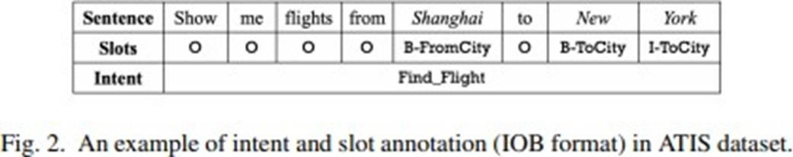

#### NLU Model Architecture:

Three modules make up the basic multitask architecture for intent detection and slot filling: phrase encoding, intent classification, and slot tagging

* + - Sentence Encoding: A vector is allocated to each input word. A BLSTM encoder is used to get hidden vectors.
    - Intent Classification: An attention model is utilized to gather a sentence embedding, which is then input into a linear output layer for intent classification.
    - Slot filling: Slot filling is a sequence labelling problem in which each input word is labelled in the same order. There are three typical ways for slot tagging in terms of time series dependency: BLSTM-SoftMax, BLSTM- CRF, and BLSTM-focus.

**Slot-Value Summary:** Although we can acquire a sequence of slot tags as a result of slot tagging, this is a half-finished representation that does not provide the value for each predicted slot. By matching the predicted tag sequence to the input phrase, we can quickly extract a summary of slot-value pairings. For example, the list of slot-value combinations for the sample in Fig. 2 is (From City=Shanghai, To City=New York).

#### Sentence-to-Semantic Generation:

* + - The dual task of NLU, which is described as a semantic-to-sentence generation (SSG) issue.
    - Sequence-to-sequence encoder-decoder architectures have shown success in natural language generating applications including machine translation conversation synthesis and text summarization. Figure 3 displays the proposed SSG architecture.
    - Encoder: We employ a hierarchical BLSTM to encode the list of slot-value pairs at the local and global levels.
    - Decoder: The semantically controlled LSTM (SC-LSTM) is utilized in sequence Figure 3 depicts the suggested design for NLU's dual task, which consists of an encoder and a decoder.

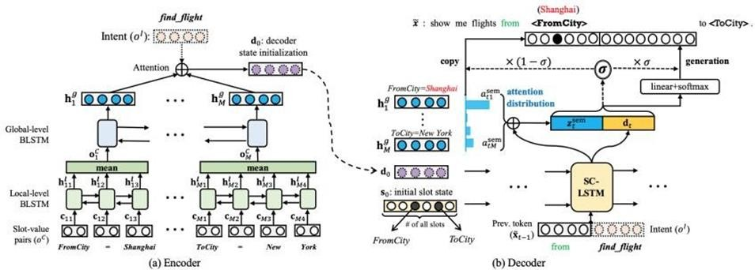

Figure 3 depicts the suggested design for NLU's dual task, which consists of an encoder and a decoder.

## Modules to be implemented

* In this study, we use a dual semi-supervised framework with two methods: dual pseudo-labeling and dual learning to solve the NLU issue.
* Our proposed methodologies' performance is compared to the baselines. Finally, extensive ablation experiments are performed in order to analyze the outcomes.

## Module description

#### Dual semi-supervised framework:

1. **Dual pseudo-labelling:**

Target labels that are applied to unannotated data as if they were genuine labels are known as pseudo-labels. We start by using a supervised technique to pre-train the NLU and SSG models using tagged data. The NLU model may be used to create a pseudo label y1 from an unlabeled text x. Using the SSG model with an unexpressed semantic form y, we can also retrieve x1 symmetrically. To put it another way, we can construct faux training samples (x, y1) in addition to the present labelled data (x1, y). The NLU and SSG models may be fine-tuned with pseudo-samples by decreasing losses, in addition to the supervised training stage utilizing labelled data.

* + We generate pseudo-samples in the labelled data based on a phrase x and a semantic form y, in addition to unlabeled x and unexpressed y. Because it has the potential to correct annotation noise while also generating multiple phrases for the same semantic structure.

#### Dual learning method:

We recommend utilizing the dual learning method, which includes simultaneously training the two models, in addition to the pseudo-labeling strategy, in which the NLU and SSG models are updated independently. We use one agent to represent the primary task model (NLU) and another to represent the dual task model (SSG). A two-agent game is then built in a closed loop to provide quality feedback to the primal and dual models even when just words or semantic forms are provided. Because the feedback incentives are non-differentiable, a policy gradient optimization strategy is applied.

As illustrated in Fig. 4, two agents, NLU and SSG, play in the collaborative game with two directed loops.

1. The NLU2SSG loop begins with a sentence, then using agent NLU to generate a likely semantic form before employing SSG to attempt to recover the original text.
2. On the other side, the SSG2NLU loop begins. Each agent will receive high- quality feedback based on the reward functions set in the directed loops. The NLU and SSG models are trained using the labelled data.

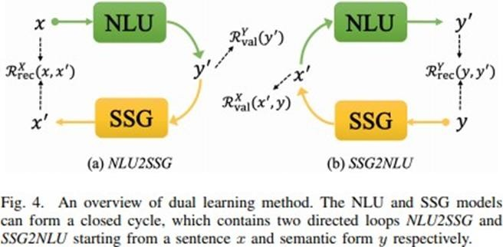

1. NLU2SSG loop: We choose a phrase x at random from the union of labelled and unlabeled data.
2. Loop SSG2NLU: We choose a semantic form y at random from labelled and unlabeled data in a symmetrical manner.
3. Reward Design: We'll go through the two validity and two reconstruction rewards offered in the two directed loops above in this section.

# Baselines:

The suggested dual semi-supervised NLU is compared to the following alternatives:

* + Supervised NLU, such as the BLSTM-SoftMax, BLSTM-CRF, and BLSTM-focus techniques outlined above, employs only labelled data for supervised learning.
  + In addition to traditional supervised learning, dual supervised learning incorporates probabilistic duality of constraint (an extra regularization term).
  + RNN-based language modelling and sequence-to-sequence based sentence auto-encoders may be utilized to use unlabeled phrases in multi- task learning with unsupervised tasks. We employ a sentence auto- encoder in our investigations.
  + Without the dual aim, traditional pseudo-labeling (PL) prepares pseudo- samples for unlabeled phrases in order to undertake data augmentation using a pre-trained NLU model.
  + Delexicalizing each input sentence from the labelled data (for example, "show me flights from (From City) to (To City)") is the first step in the template synthesis process. Then, by replacing slot types in each template with unexpressed semantic forms of the appropriate values, we construct more labelled instances for supervised training.

**Training Details**: Pre-trained Glove embeddings and character embeddings are concatenated to create word embeddings with 400 dimensions, which may be modified during training. n is the concealed size, and it is 256. The hyper-parameters α, β,γ, ω, δ are all set to 0.5, and experimentally, is 0.25. The beam size K is set at 5 for dual learning. Except for the pre-trained word embeddings, the network parameters are randomly initialized using a uniform distribution [0.2, 0.2]. For all trials, we employ Adam [65] with a learning rate of 0.001. During the training phase, non-recurrent connections are dropped with a frequency of 0.5. The batch size for all datasets is 16. To avoid over-fitting, we set the maximum norm for gradient clipping to 5, and we use l2 norm regularization with factor-5 on all weights. For 50 epochs, we keep the learning rate constant and save the parameters with the best validation set performance. Finally, we present the intent accuracy and F1-score of

slot-value pairs with parameters that have the best average of intent accuracy and slot F1-score on the validation set on the test set. The F1-score is calculated using the CoNLL assessment script.

Semi-supervised learning data settings: To evaluate the efficacy and efficiency of various semi-supervised NLU algorithms, we describe the semi-supervised learning data settings below. A subset of the training set is maintained as entirely labelled data, while the remainder is left as unpaired sentences and semantic forms, imitating unlabeled data, to mimic the annotation scarcity problem in the real world. We randomly select 5, 10, 15, 20, 30, and 50% of the training set from each dataset for trials in the labelled data section.

McNemar's Test: To determine the statistical significance of one approach over another (p 0.05), we utilize McNemar's test.

## Data sets

The Airline Travel Information Systems (ATIS) dataset and the SNIPS Natural Language Understanding benchmark are used to test our suggested approaches (SNIPS). ATIS is a commonly used dataset in spoken language comprehension that collects and manually transcribes audio recordings of people making aircraft bookings. SNIPS is a crowdsourced natural language corpus that is used to test the performance of voice assistants. Table I displays the statistical information for the two datasets.

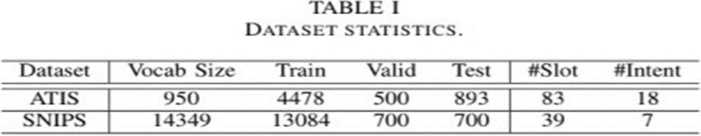

### ATIS (Airline Travel Information Systems):

The ATIS (Airline Travel Information Systems) collection contains audio recordings and hand transcripts of individuals querying automated airline travel enquiry systems for flight information. There are 17 distinct purpose types in the data.

* + - The ATIS dataset is the ideal way to describe tasks like intent recognition, semantic parsing, sql parsing, and slot filling.
    - Using discriminative machine learning algorithms and the ATIS test set, recent research revealed error rates of less than 5% for these tasks.
    - The ATIS-supported assessment approach relies on a similar representation of the response for each utterance. This is achieved by restricting the utterances to database queries and the responses to a defined set of tuples from a relational database.
    - The ATIS database was designed to represent as much of a real-world resource as feasible, and most of the queries presented by subjects may be answered from the database with a single relational query.

### SNIPS (SNIPS Natural Language Understanding benchmark):

The SNIPS Natural Language Understanding benchmark is a collection of over 16,000 crowdsourced inquiries divided into seven user intentions of varying complexity:

* + - * SearchCreativeWork (e.g. Find me the I, Robot television show),
      * GetWeather (e.g. Is it windy in Boston, MA right now?),
      * BookRestaurant (e.g. I want to book a highly rated restaurant in Paris tomorrow night),
      * PlayMusic (e.g. Play the last track from Beyoncé off Spotify),
      * AddToPlaylist (e.g. Add Diamonds to my road trip playlist),
      * RateBook (e.g. Give 6 stars to Of Mice and Men),
      * SearchScreeningEvent (e.g. Check the show times for Wonder Woman inParis).

The training set has 13,084 utterances, whereas the validation and test sets each have 700 utterances and 100 questions per intent. The task of intent detection may be accomplished utilizing the SNIPS data set and the stack propagation data model.

# Chapter 4

# Code & Execution

# Models:

# 

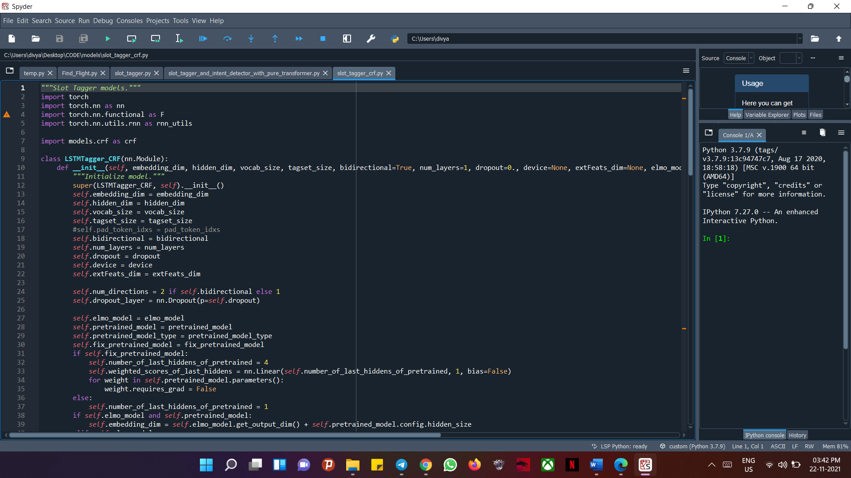

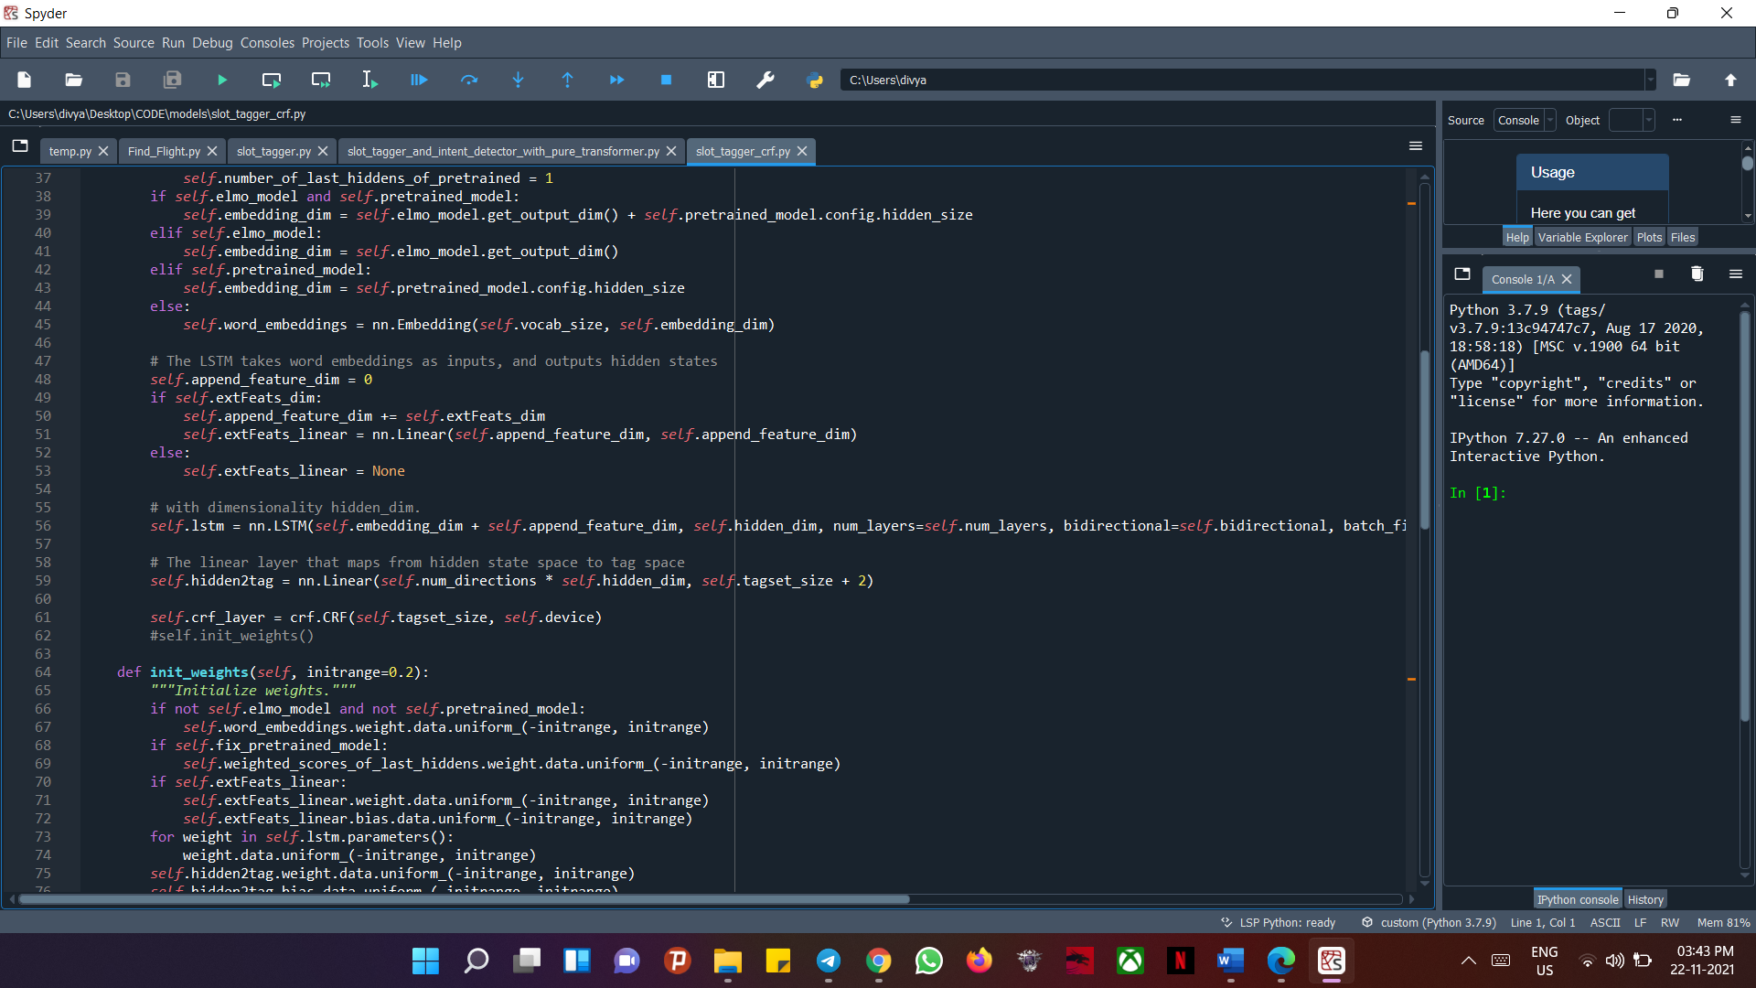

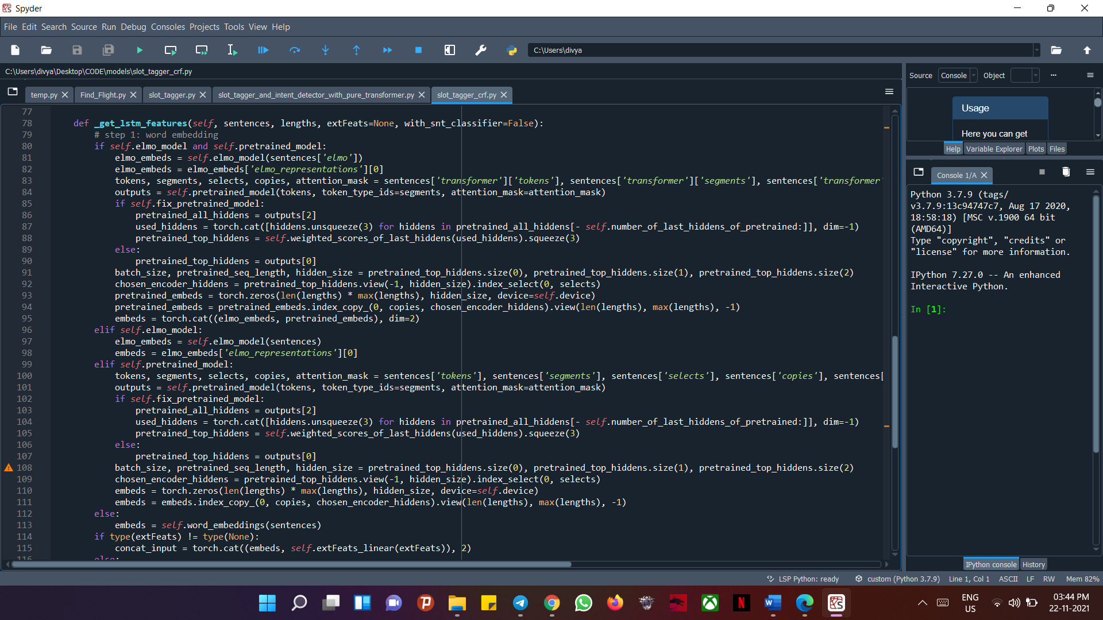

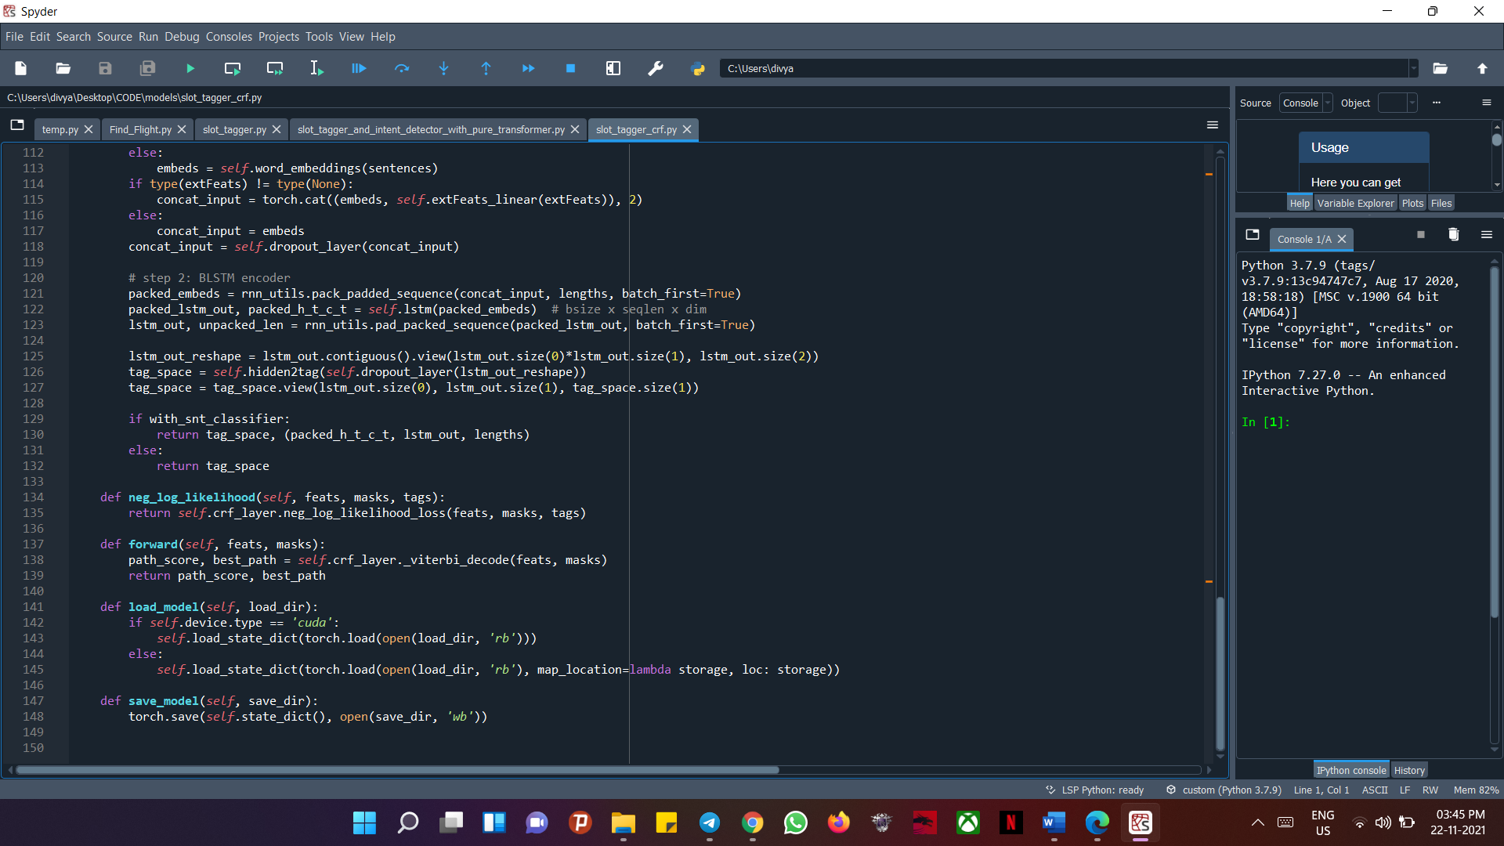

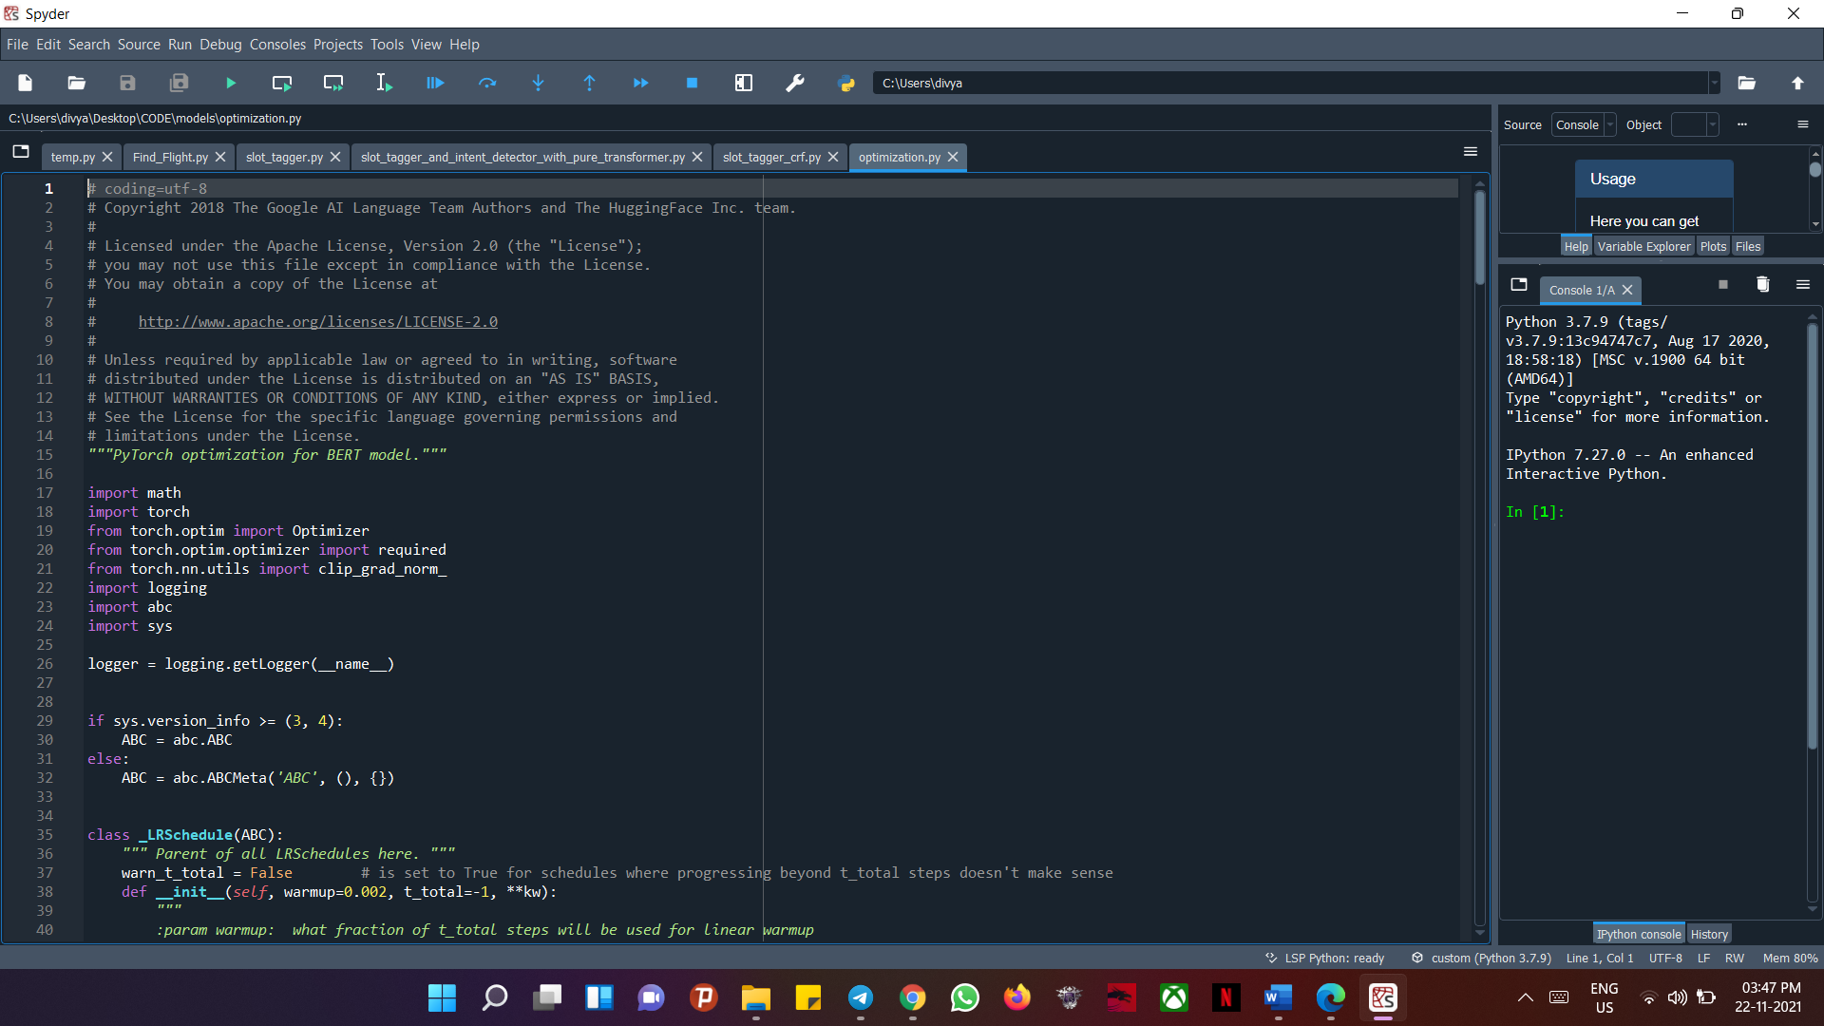

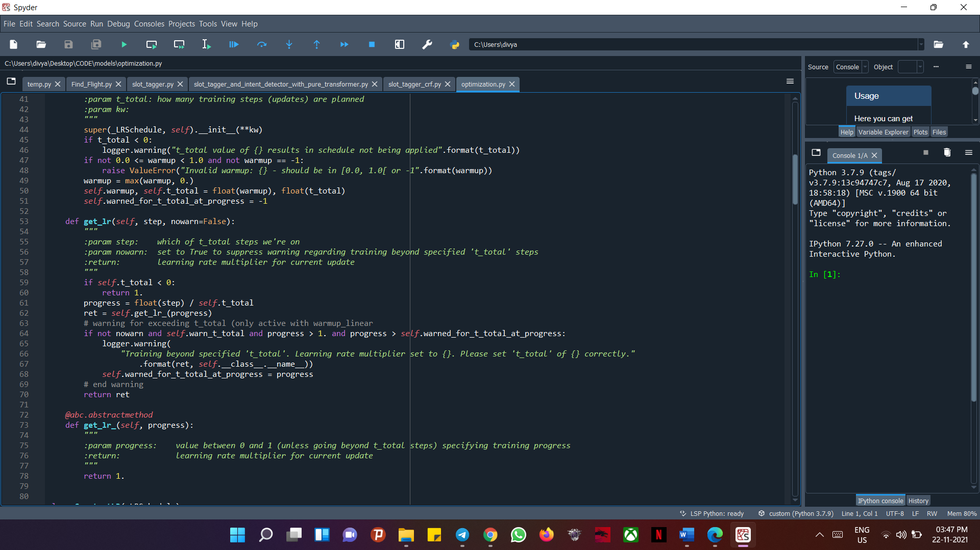

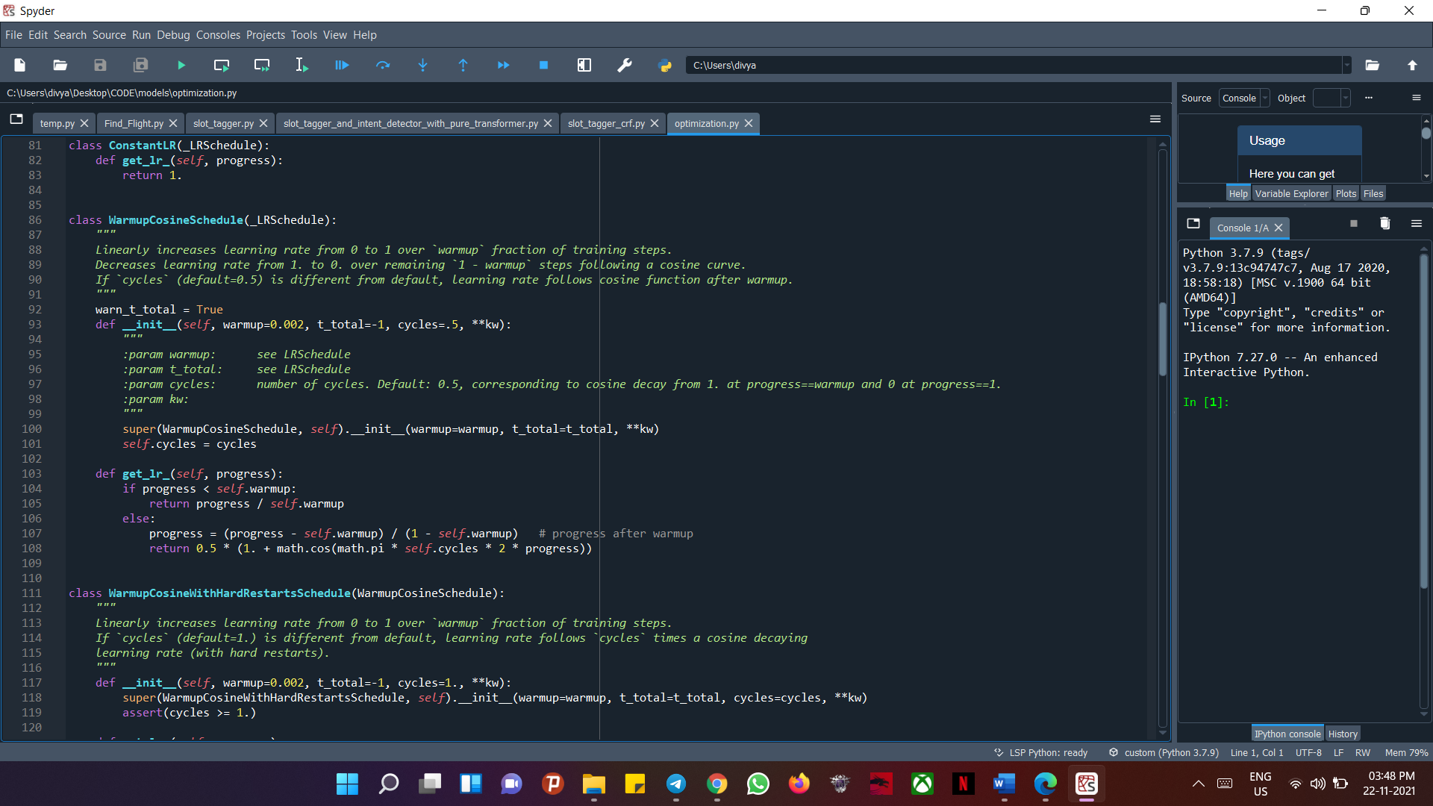

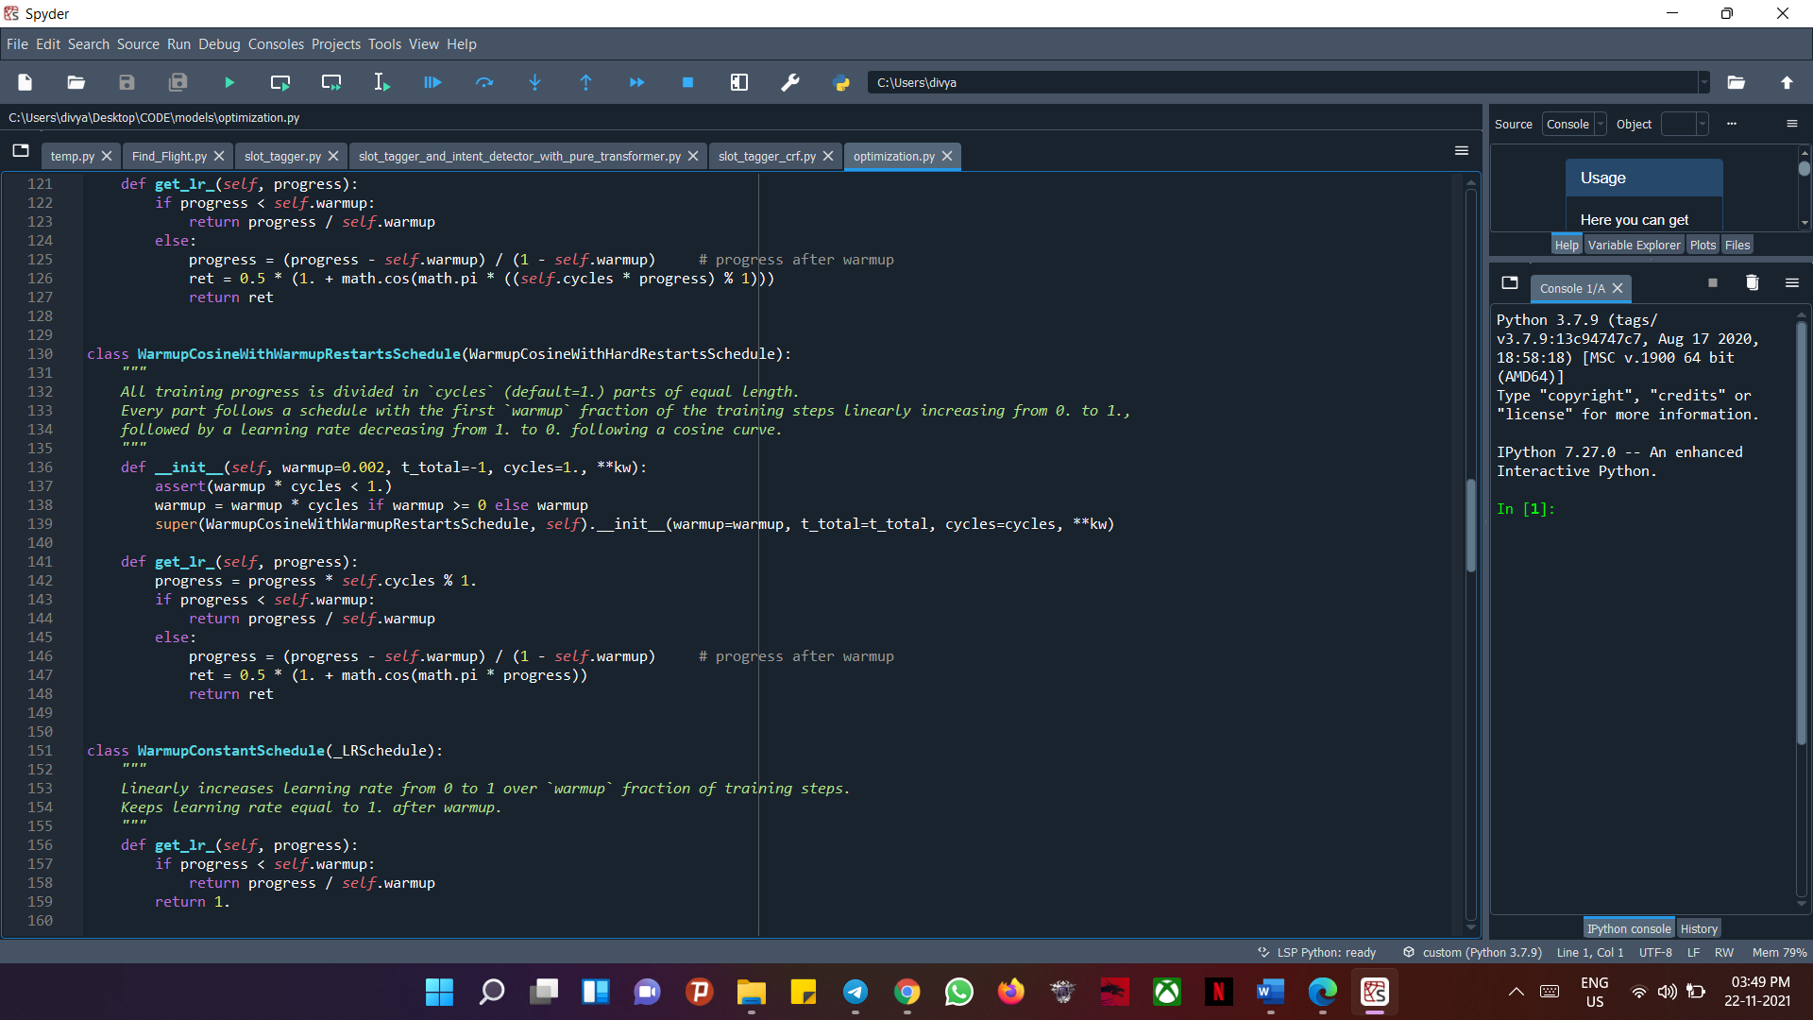

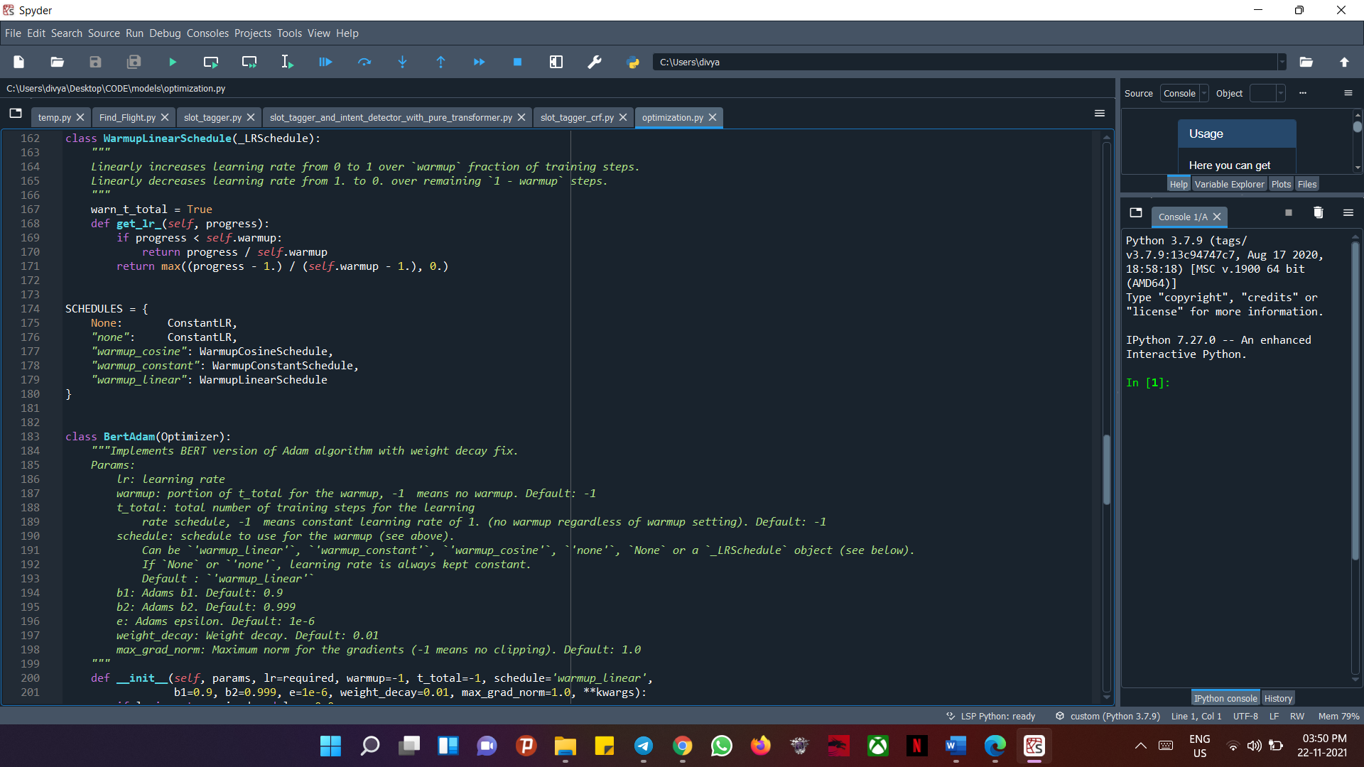

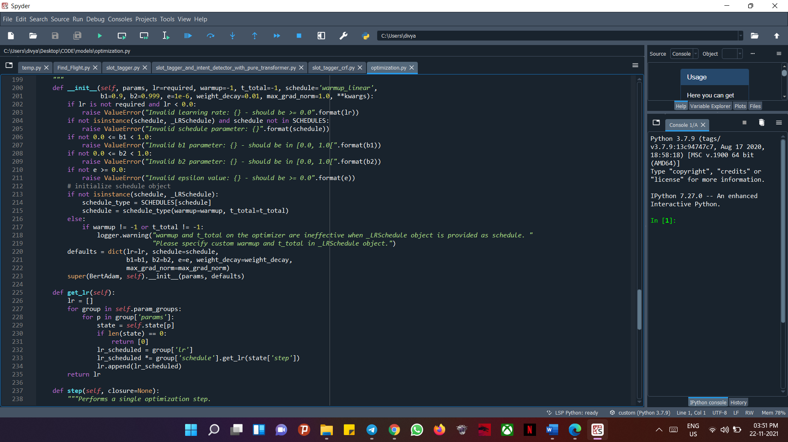

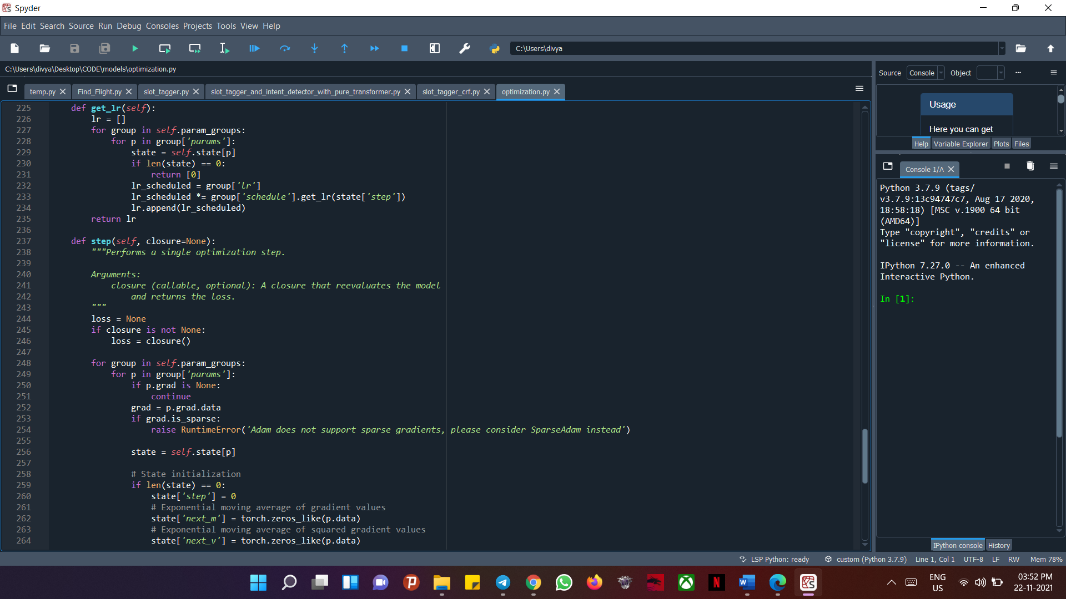

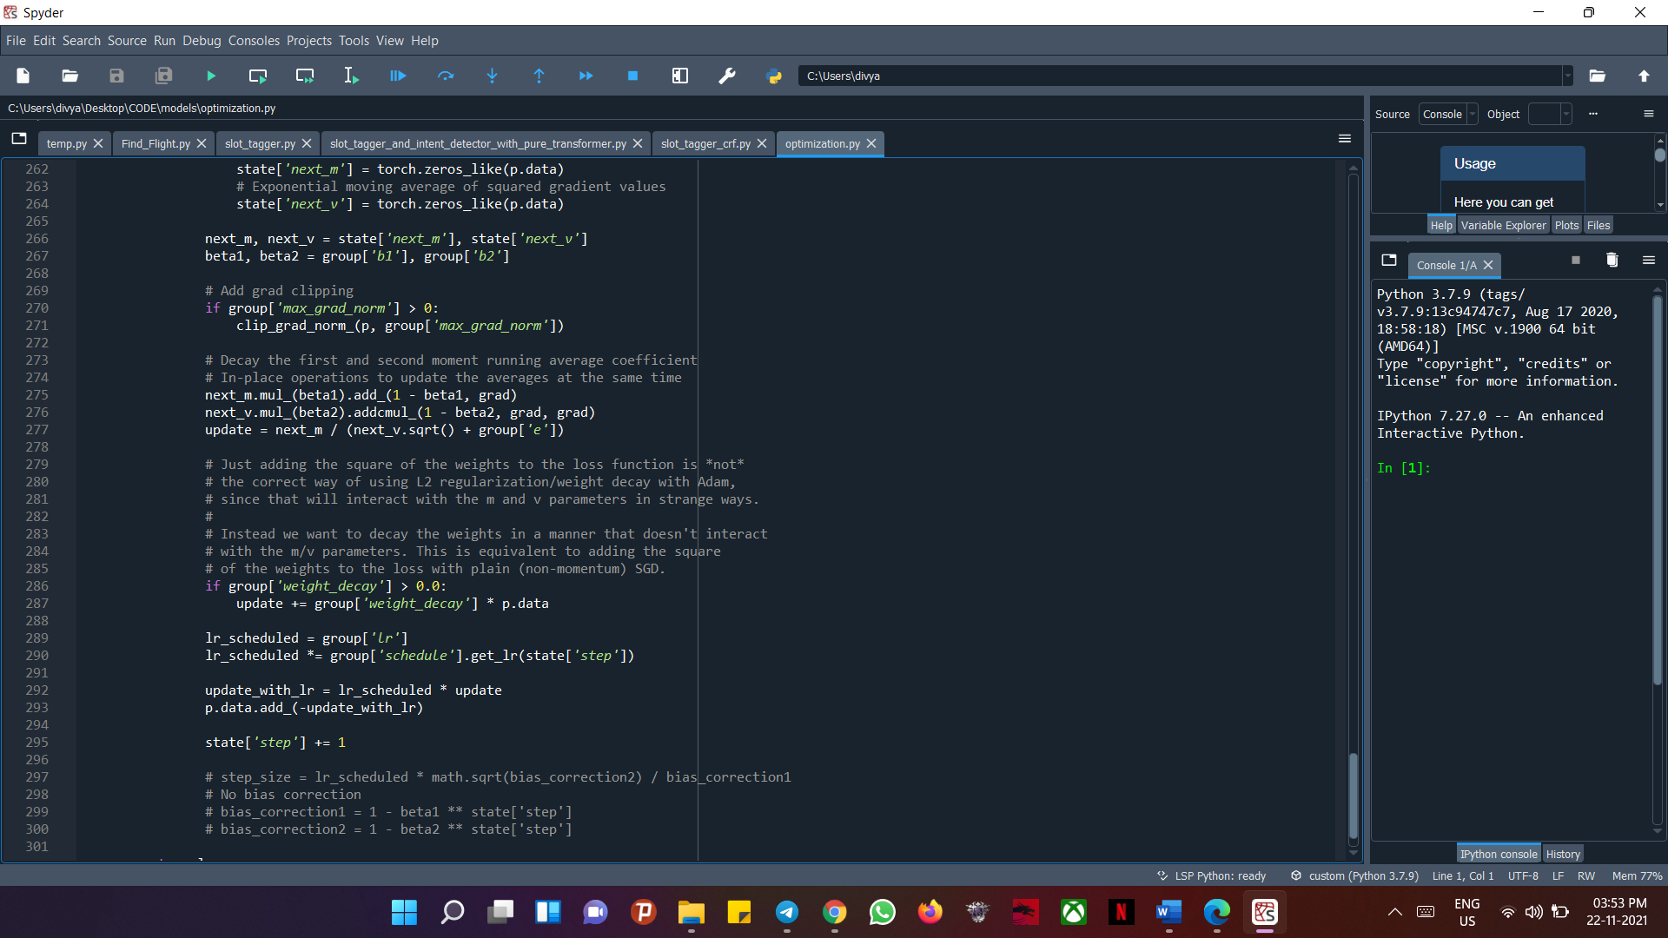

* **Utils:**

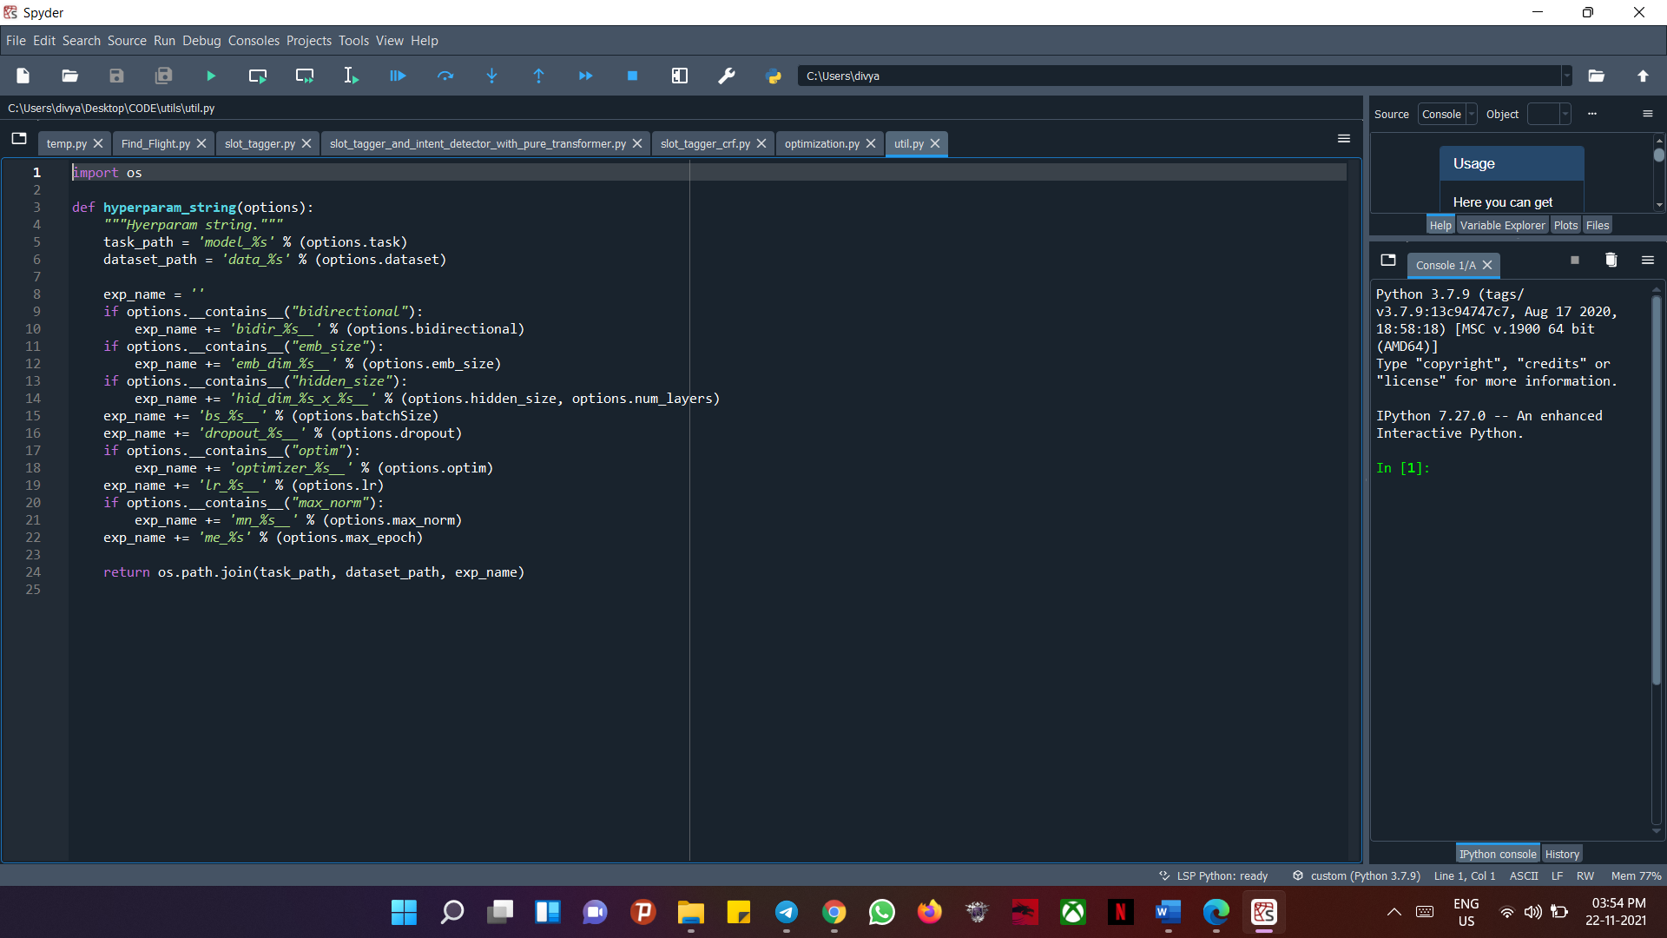

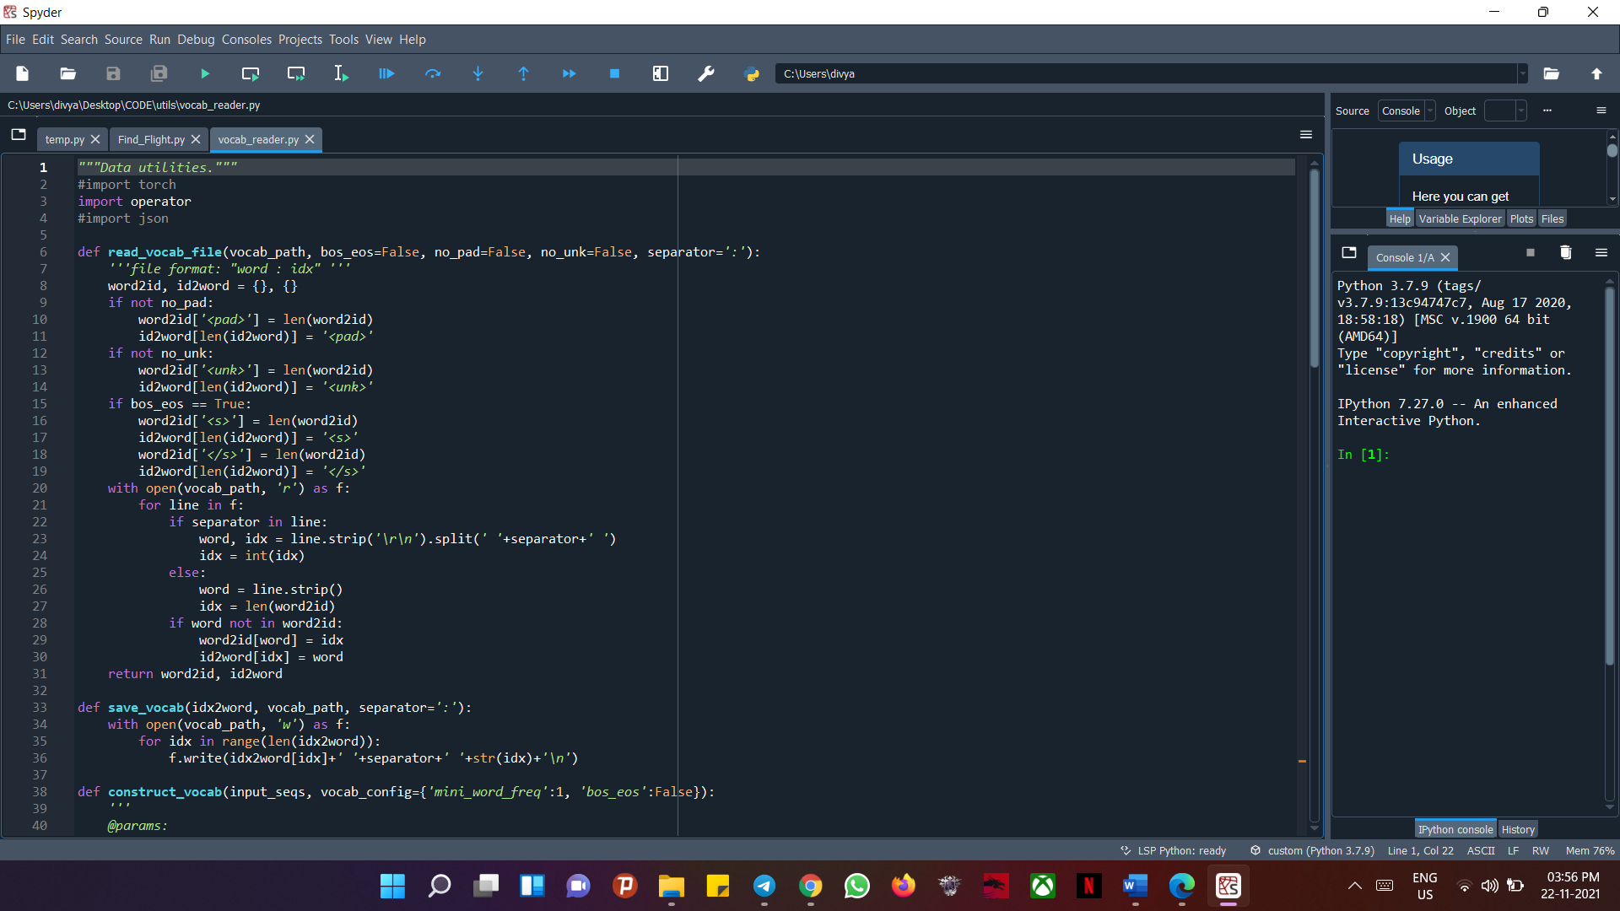

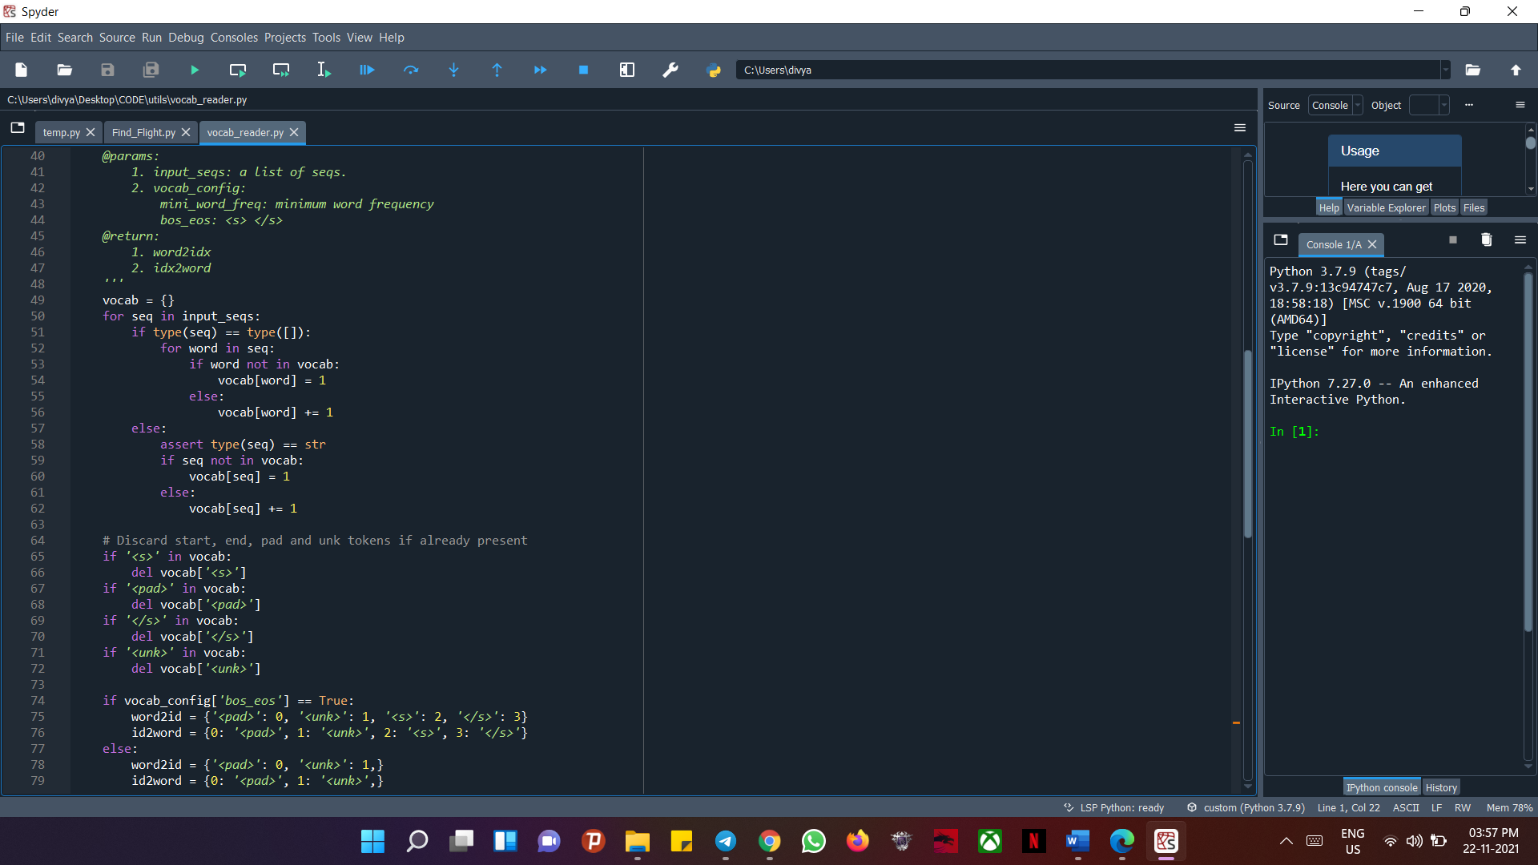

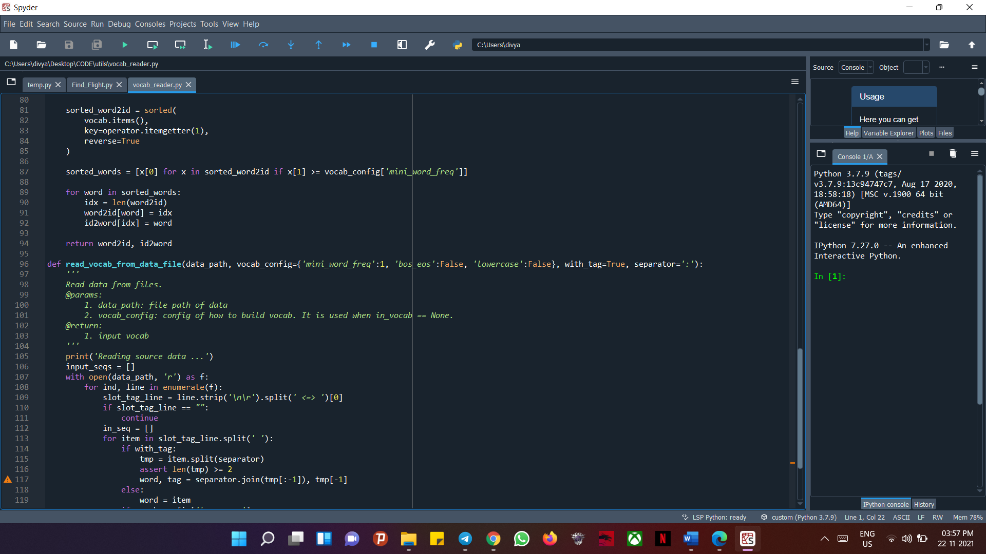

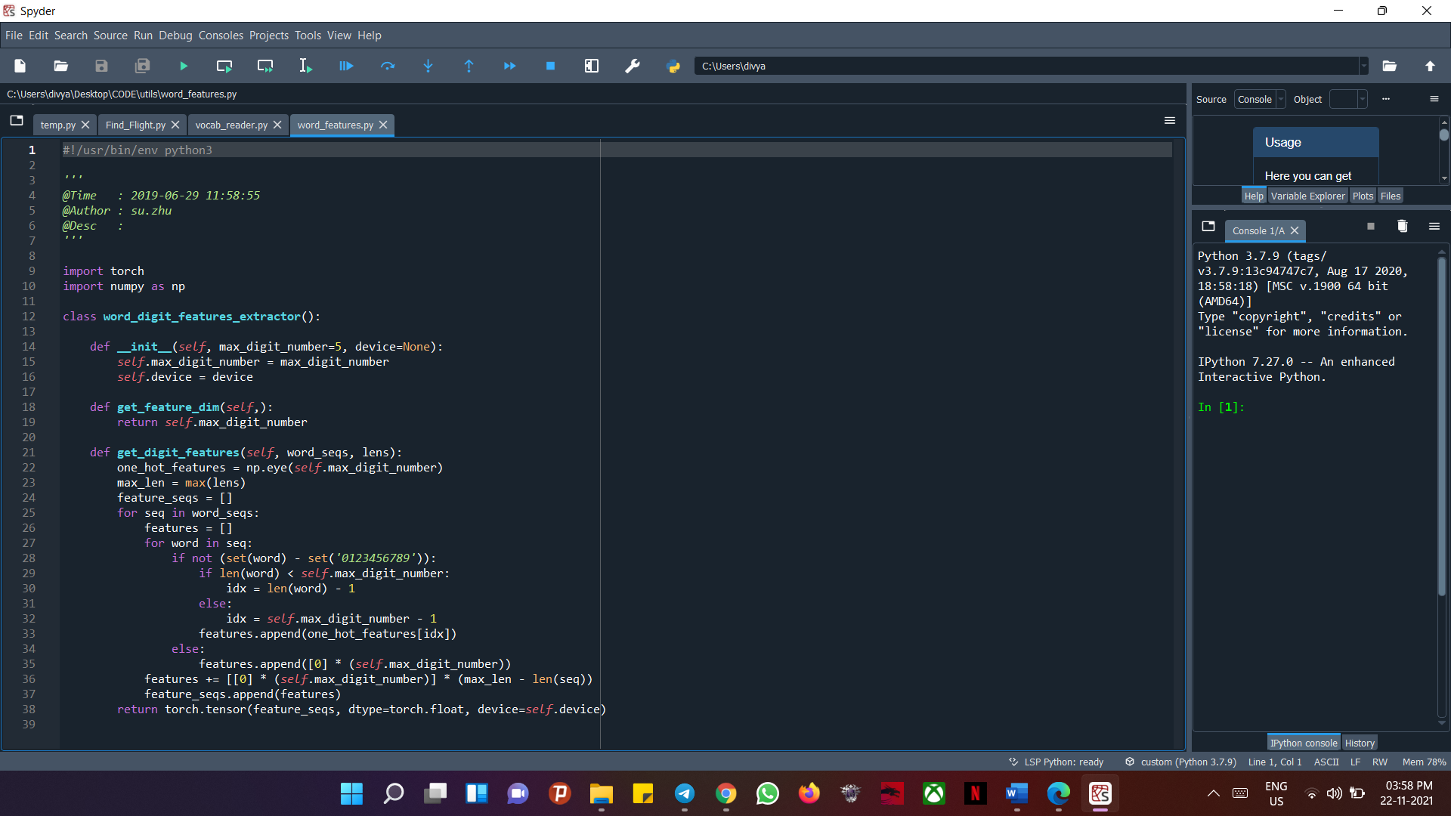

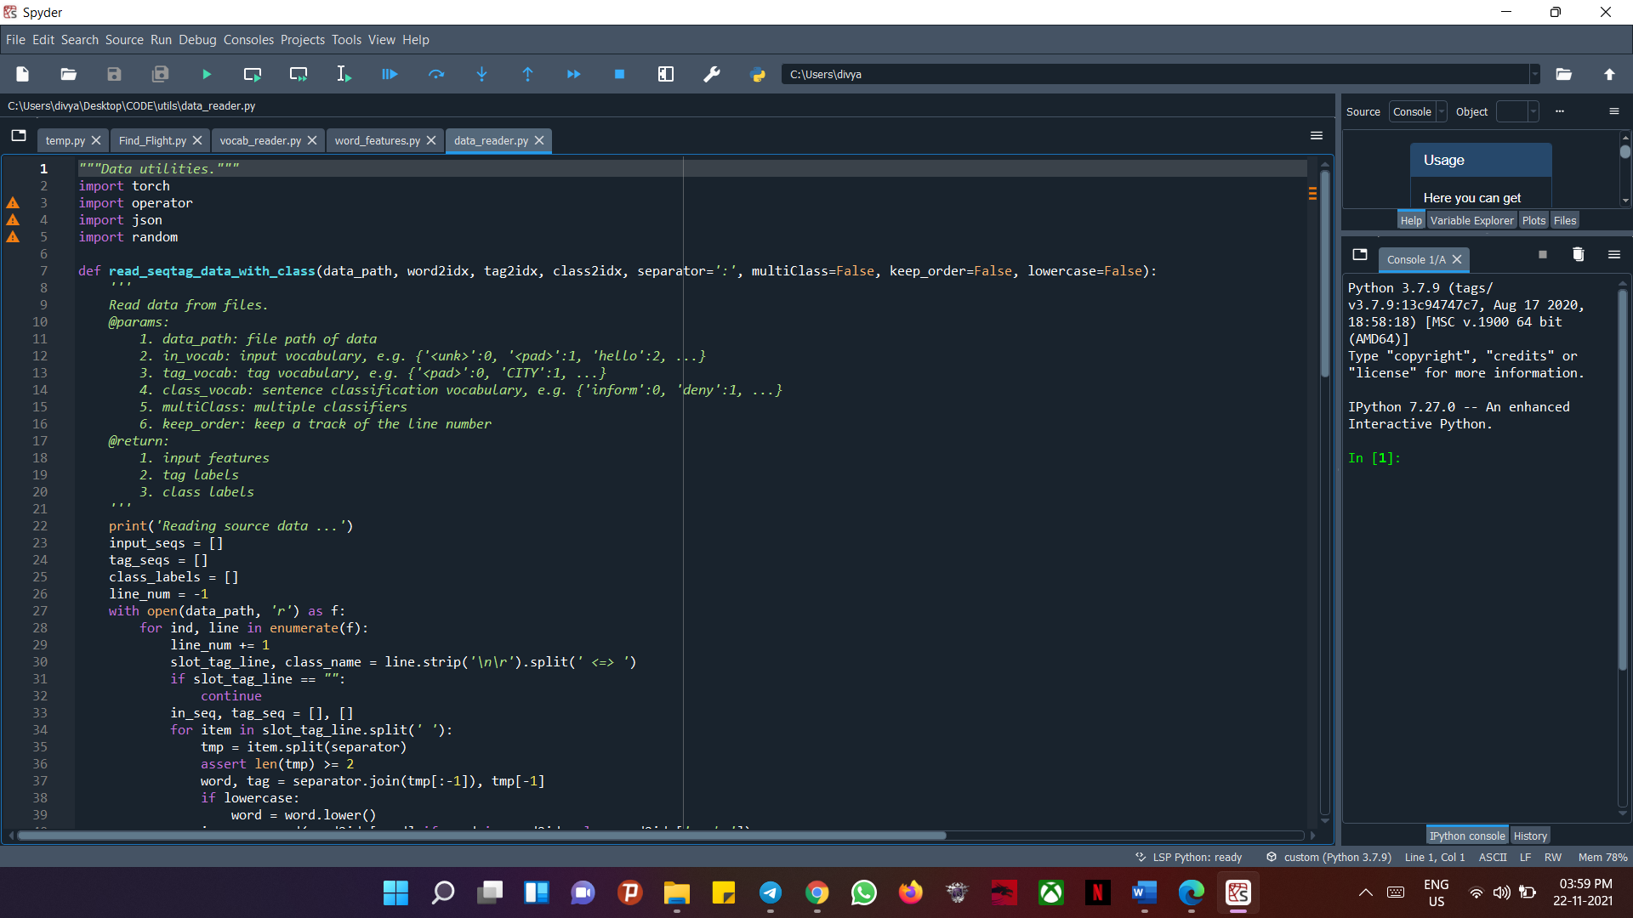

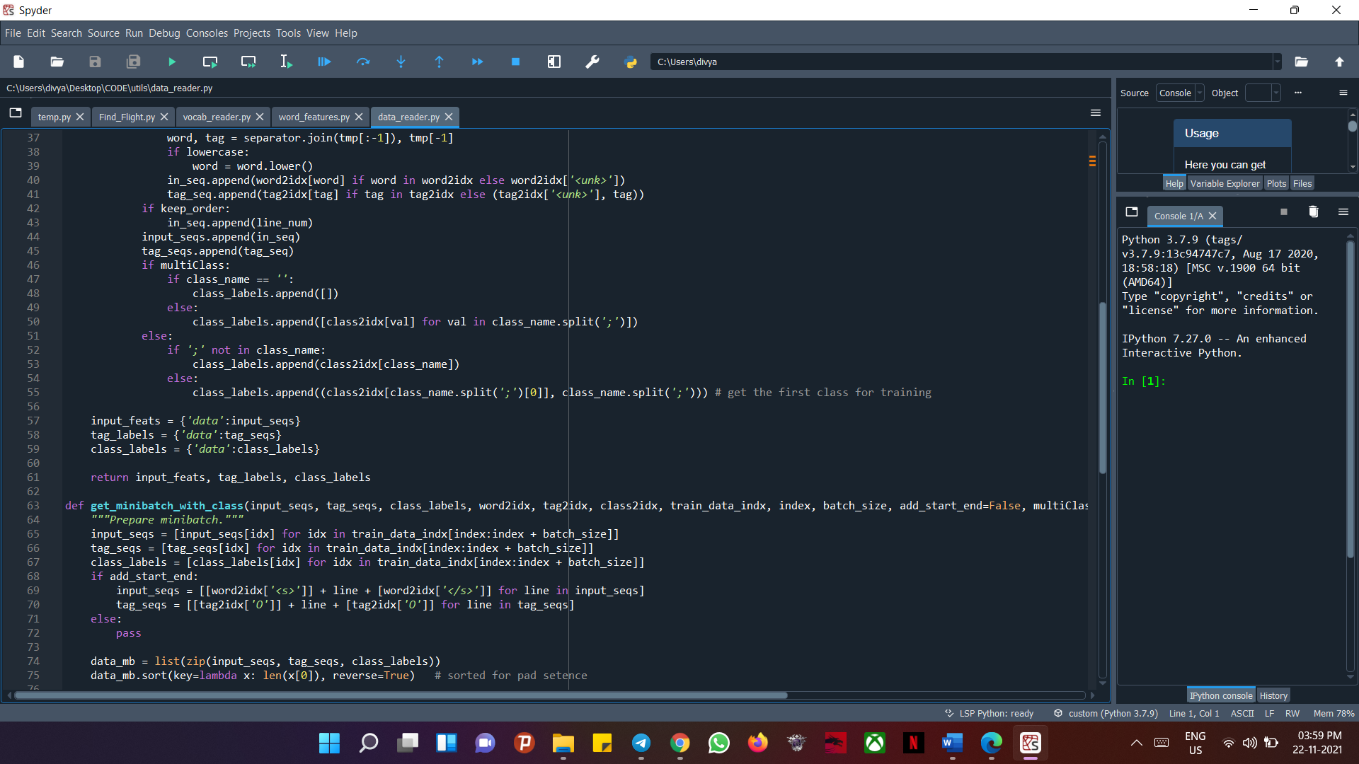

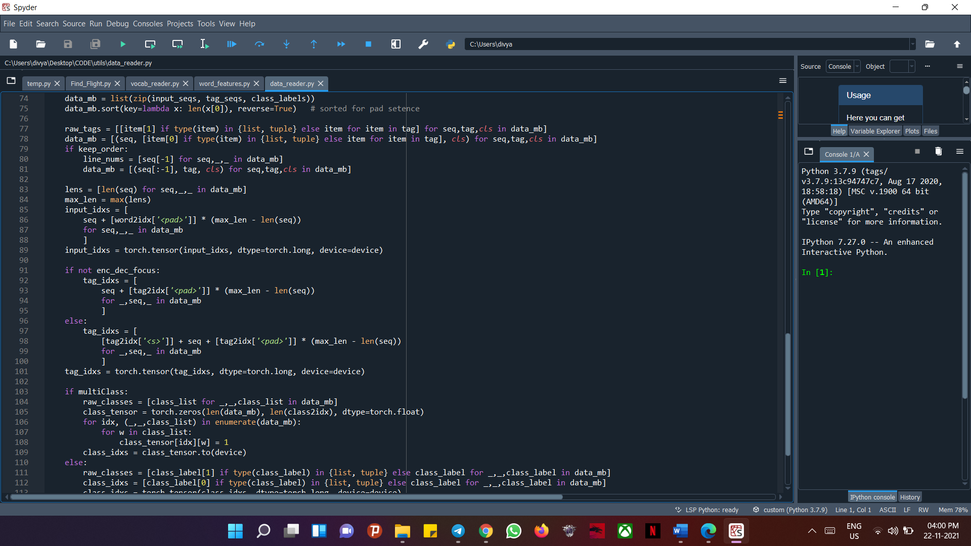

* **BLTSM:**

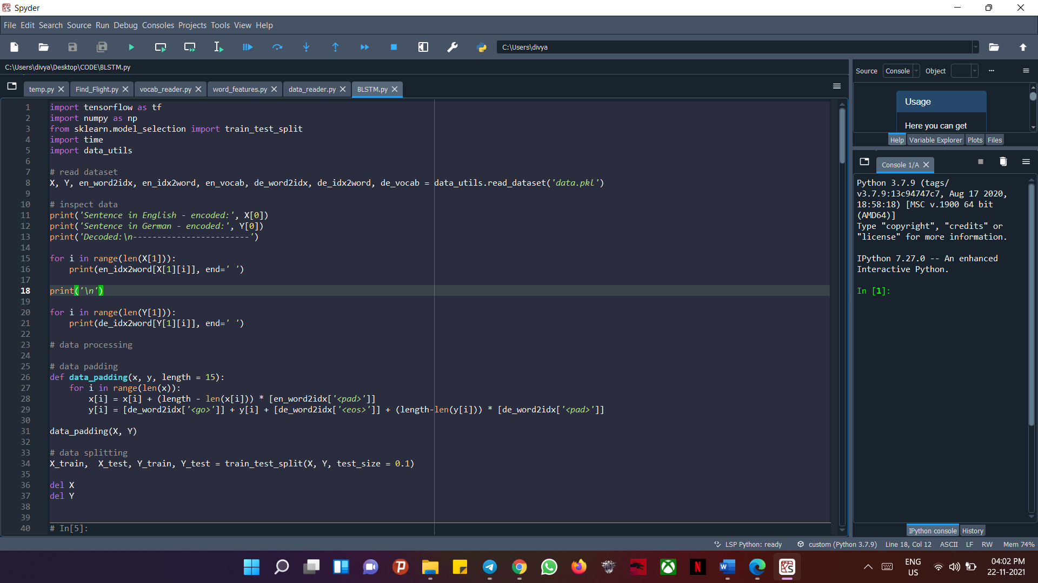

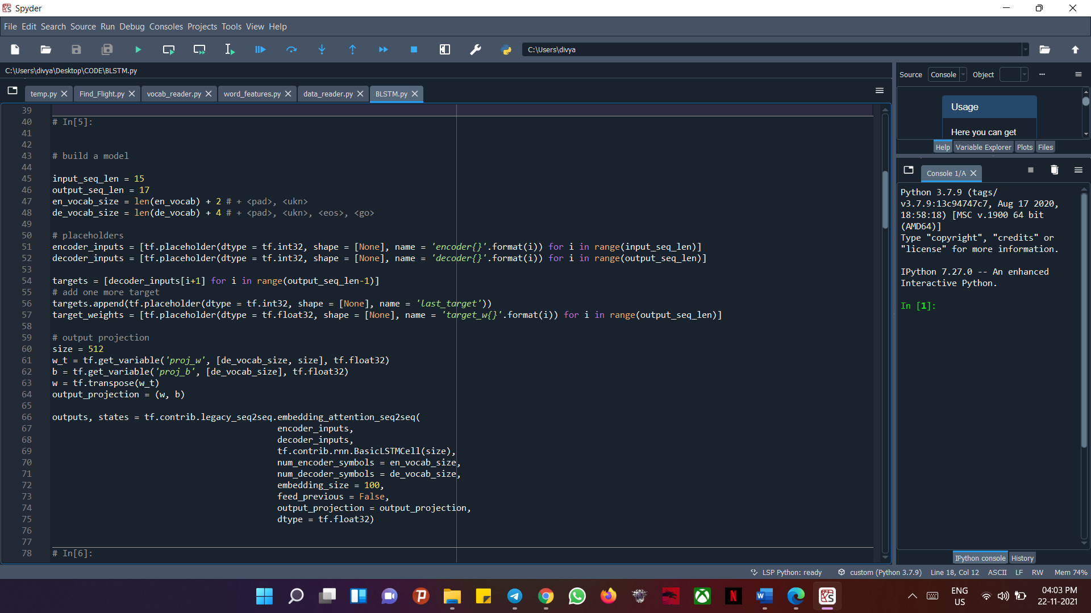

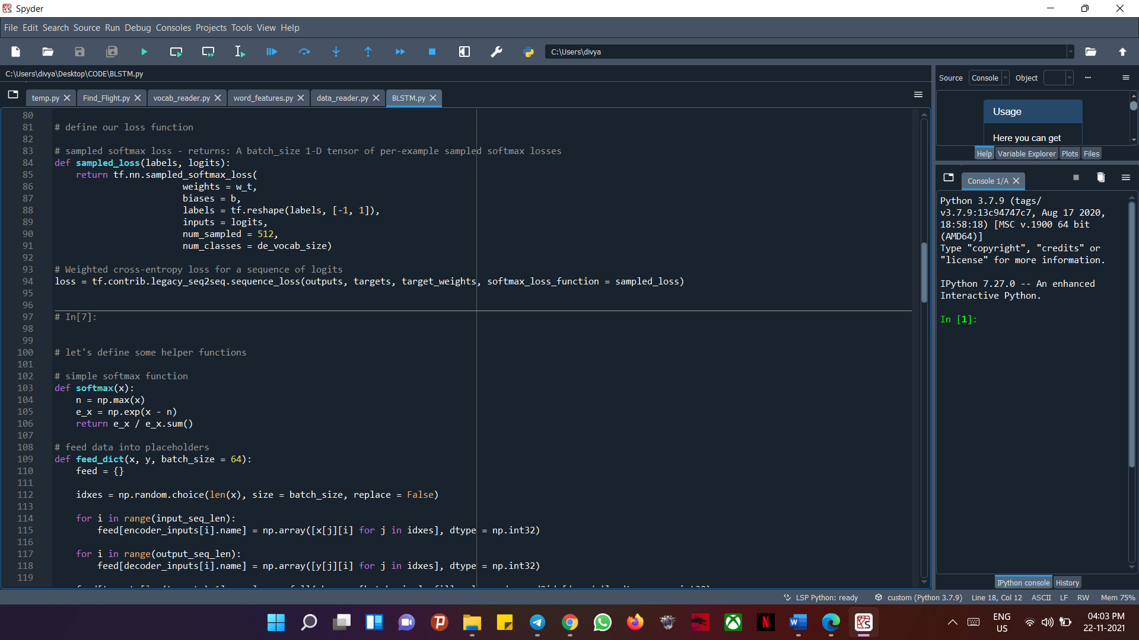

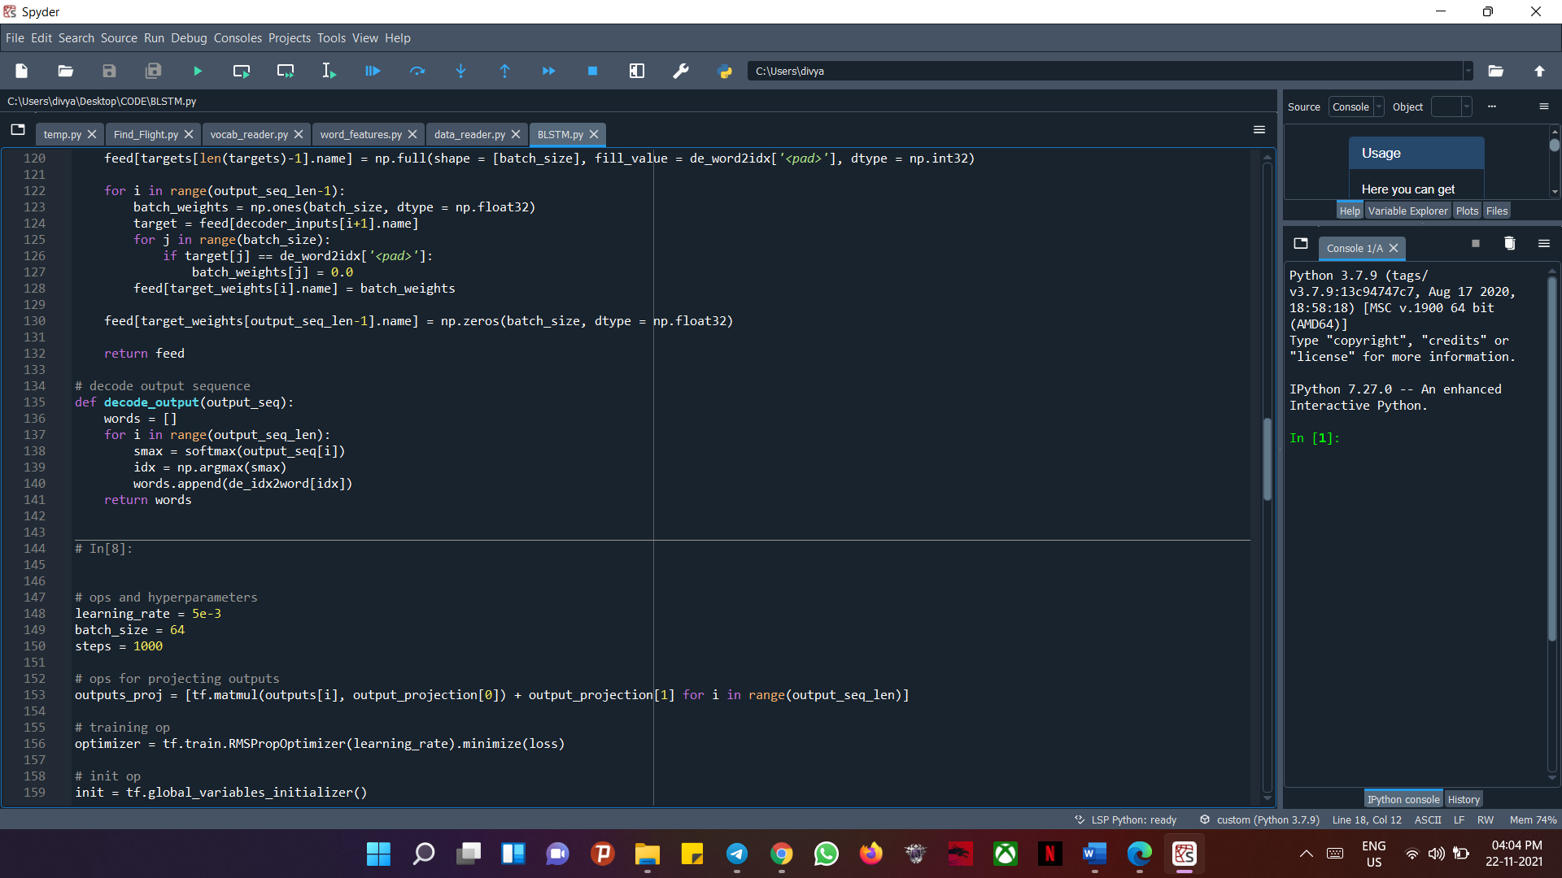

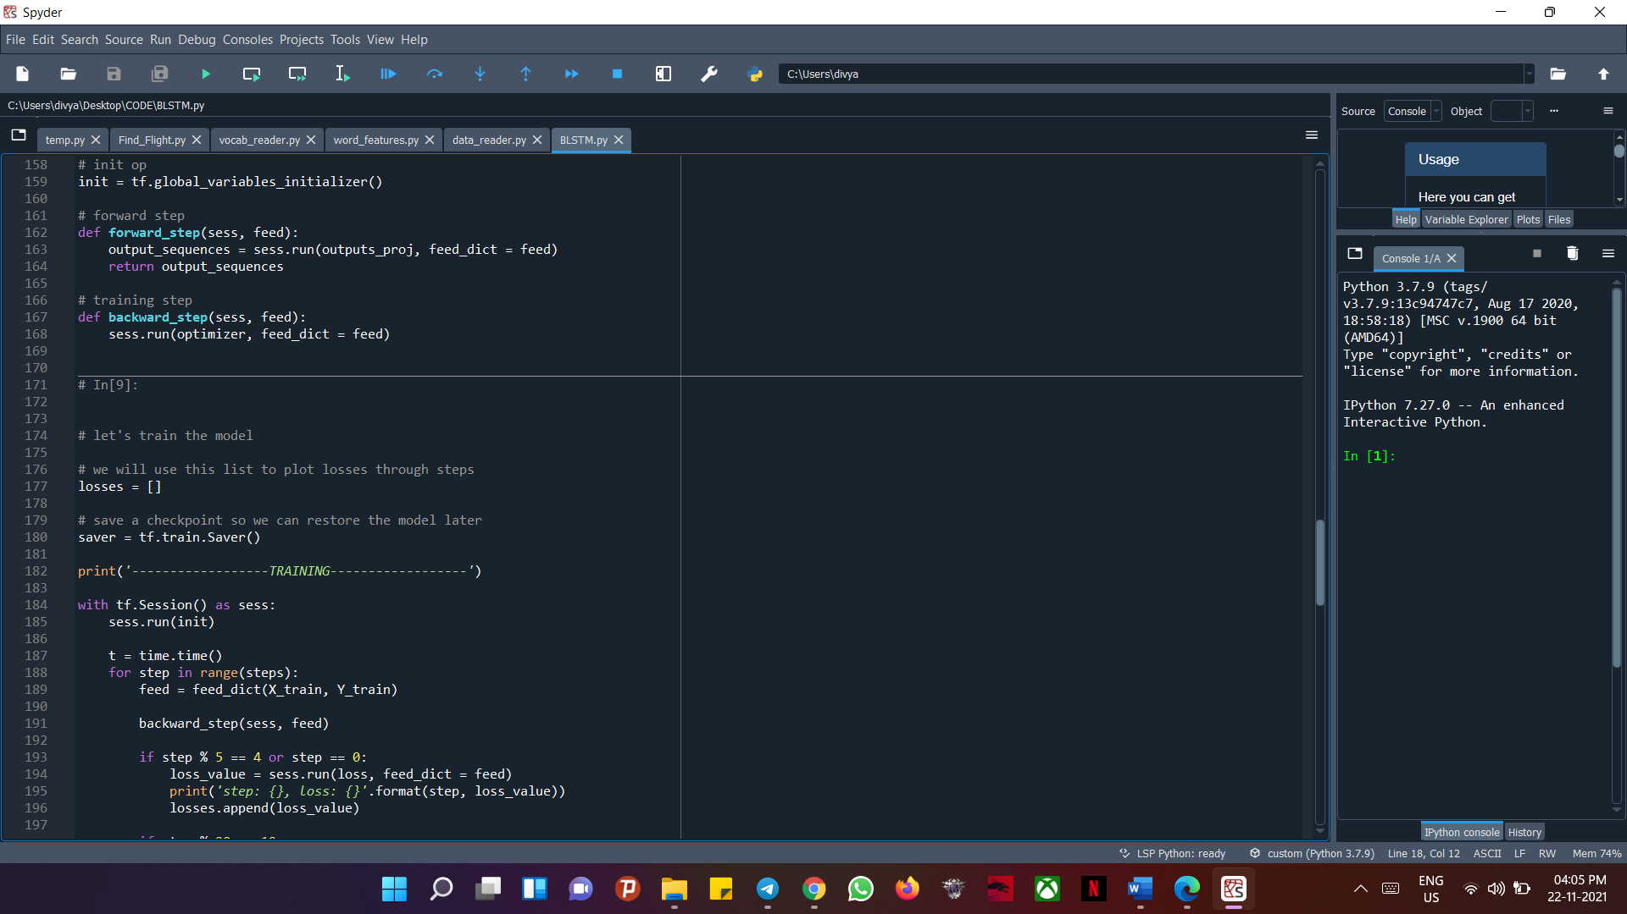

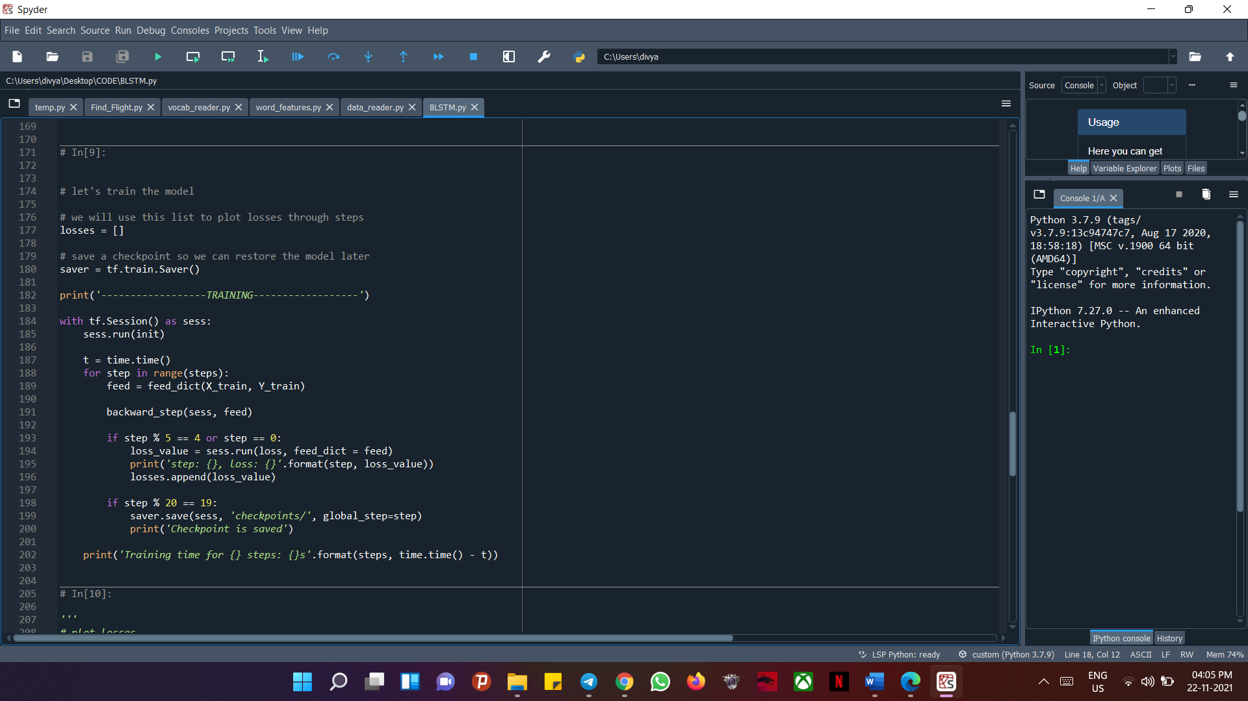

* **Word Embedding:**

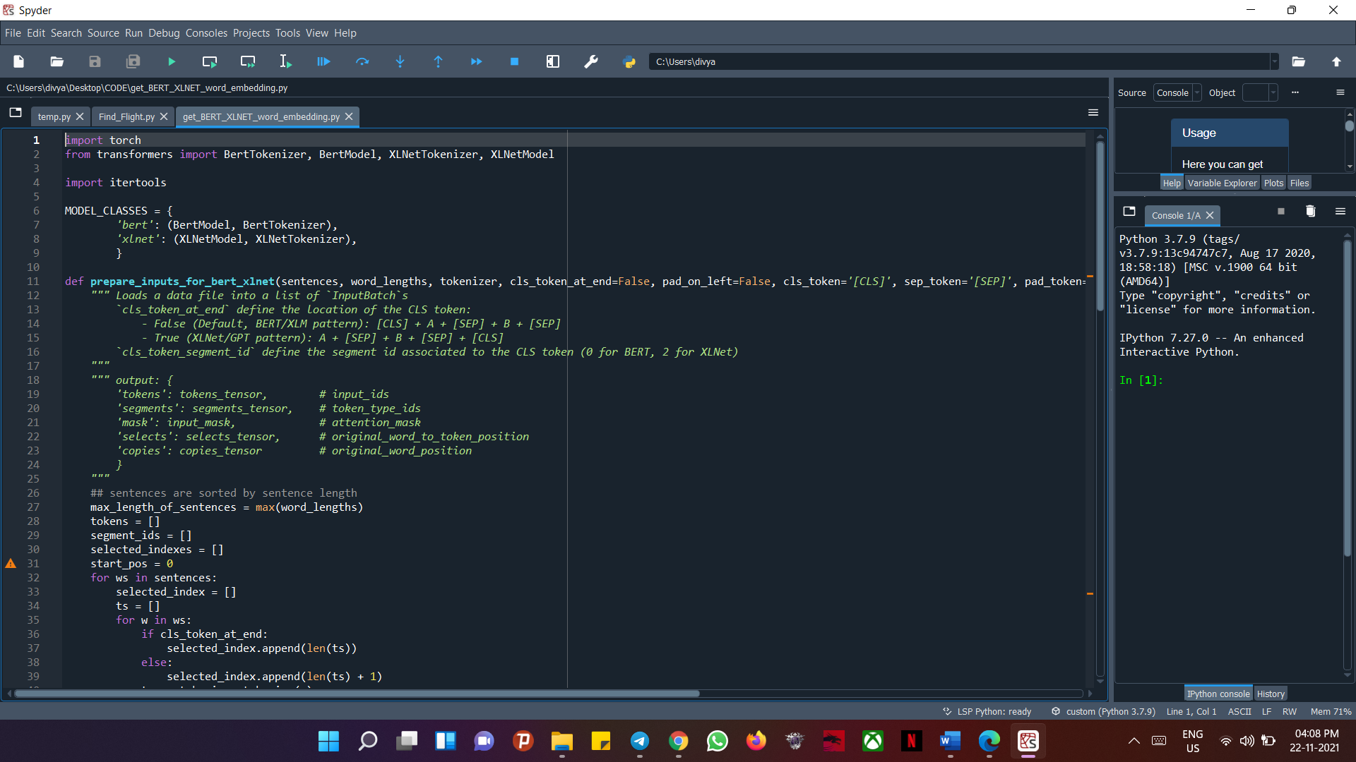

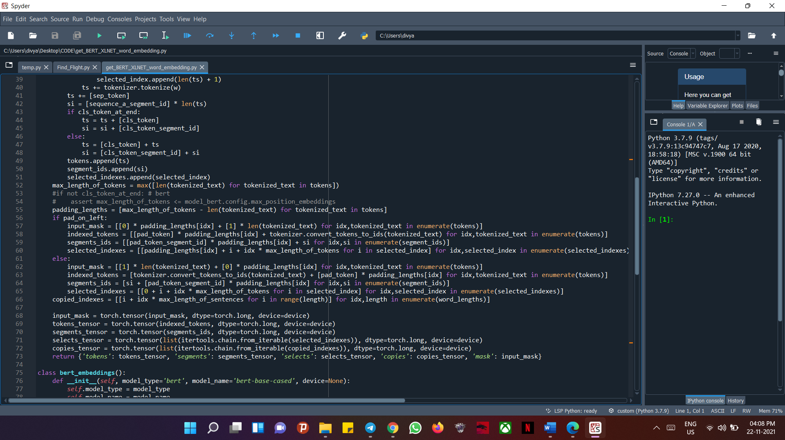

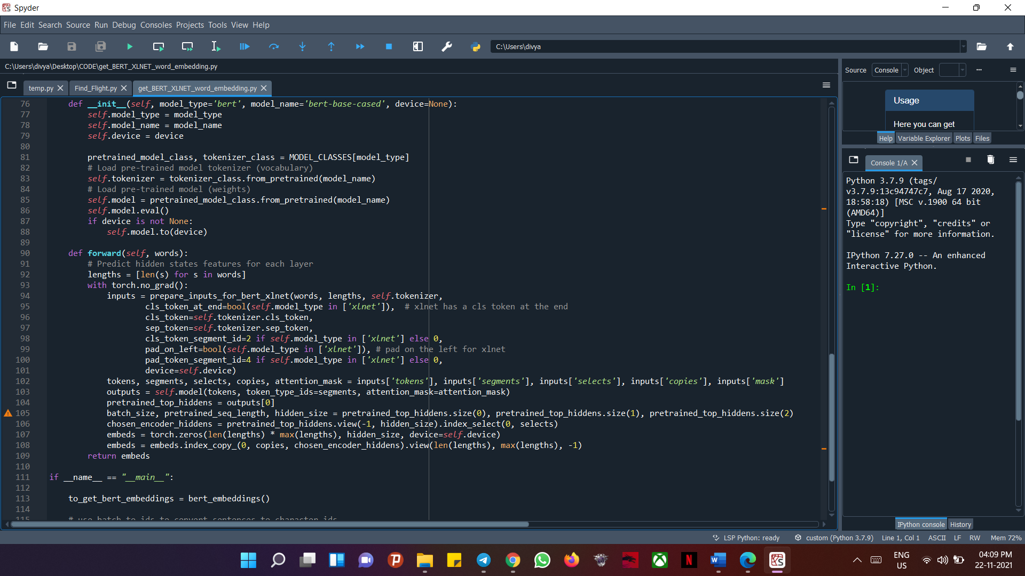

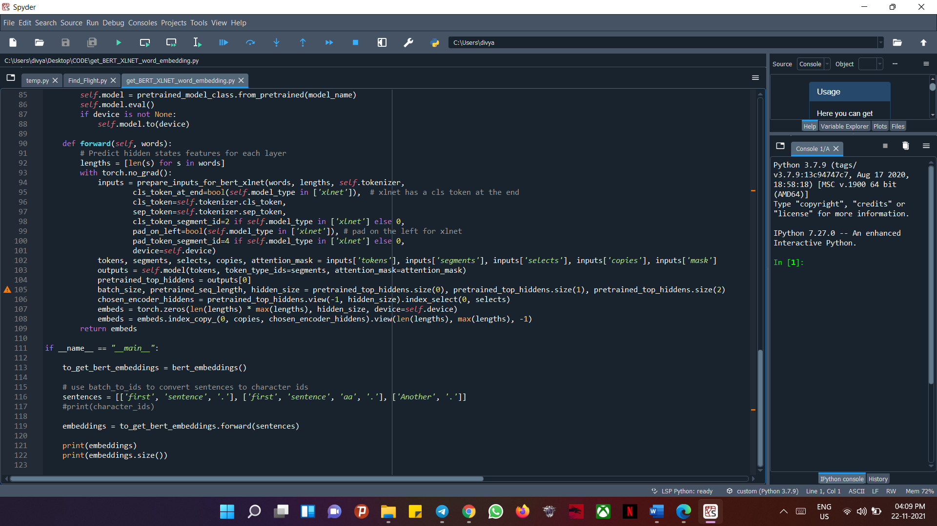

* **Testing:**

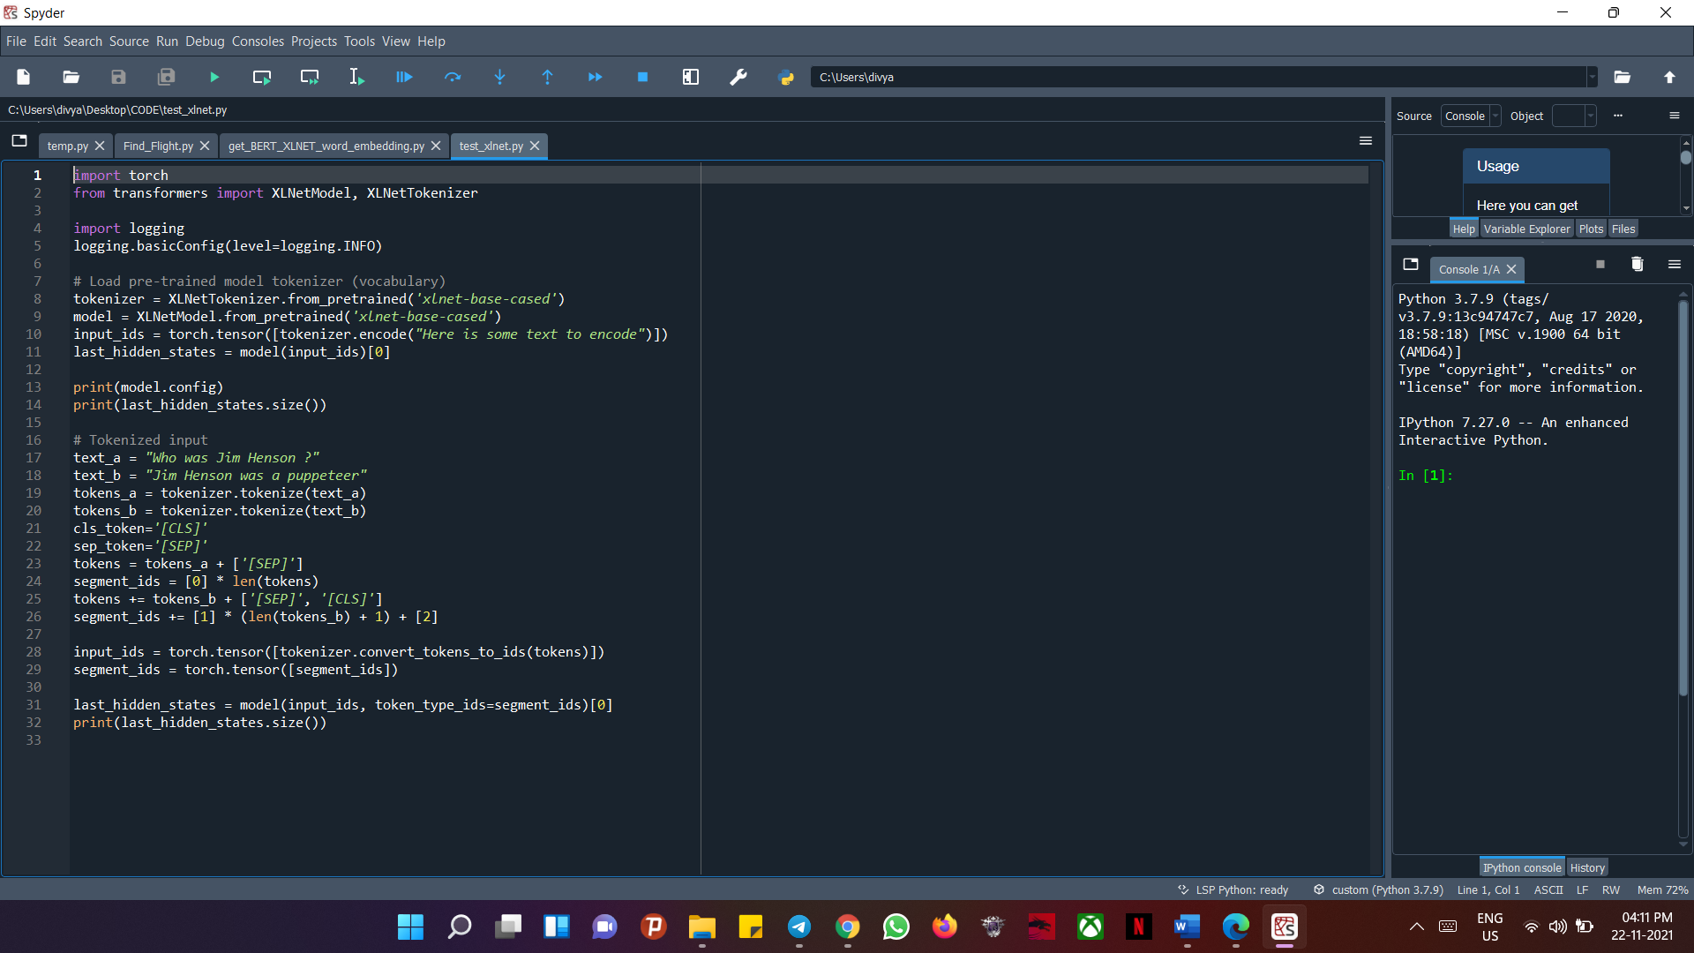

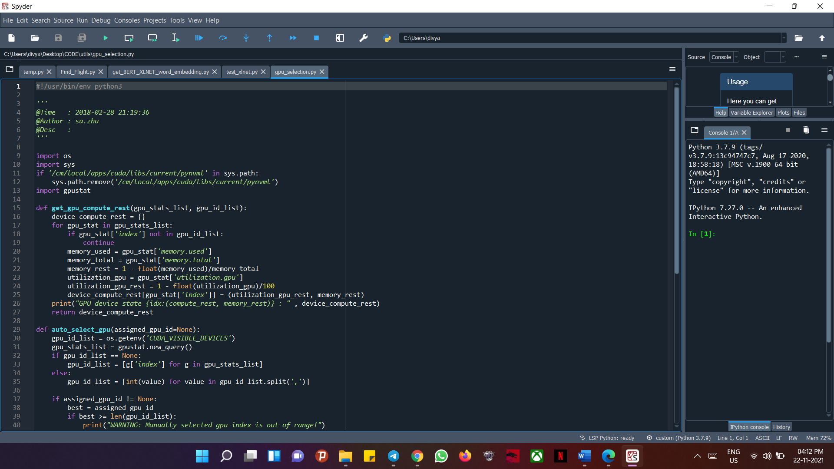

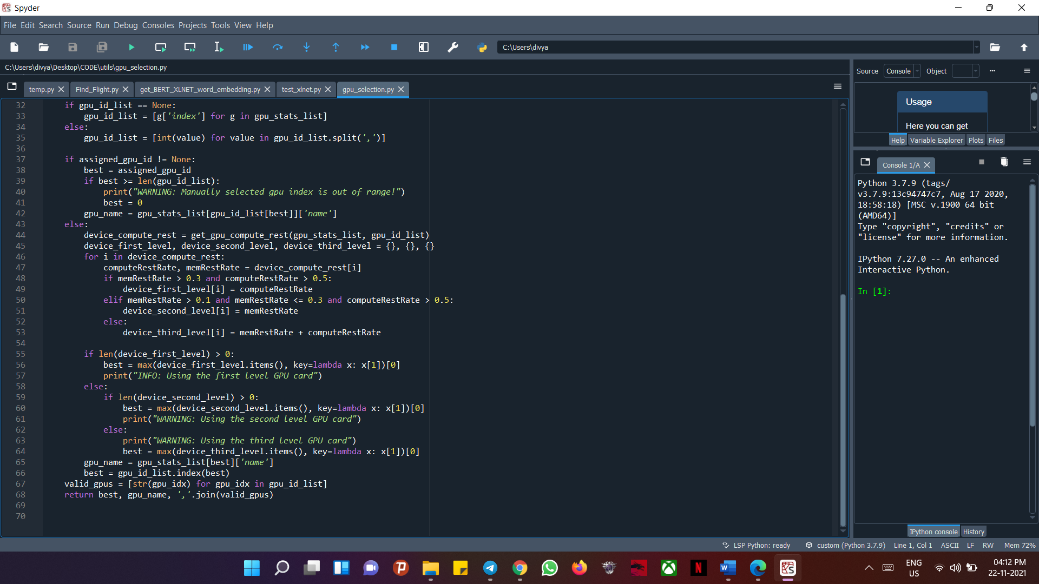

* **Language Models:**

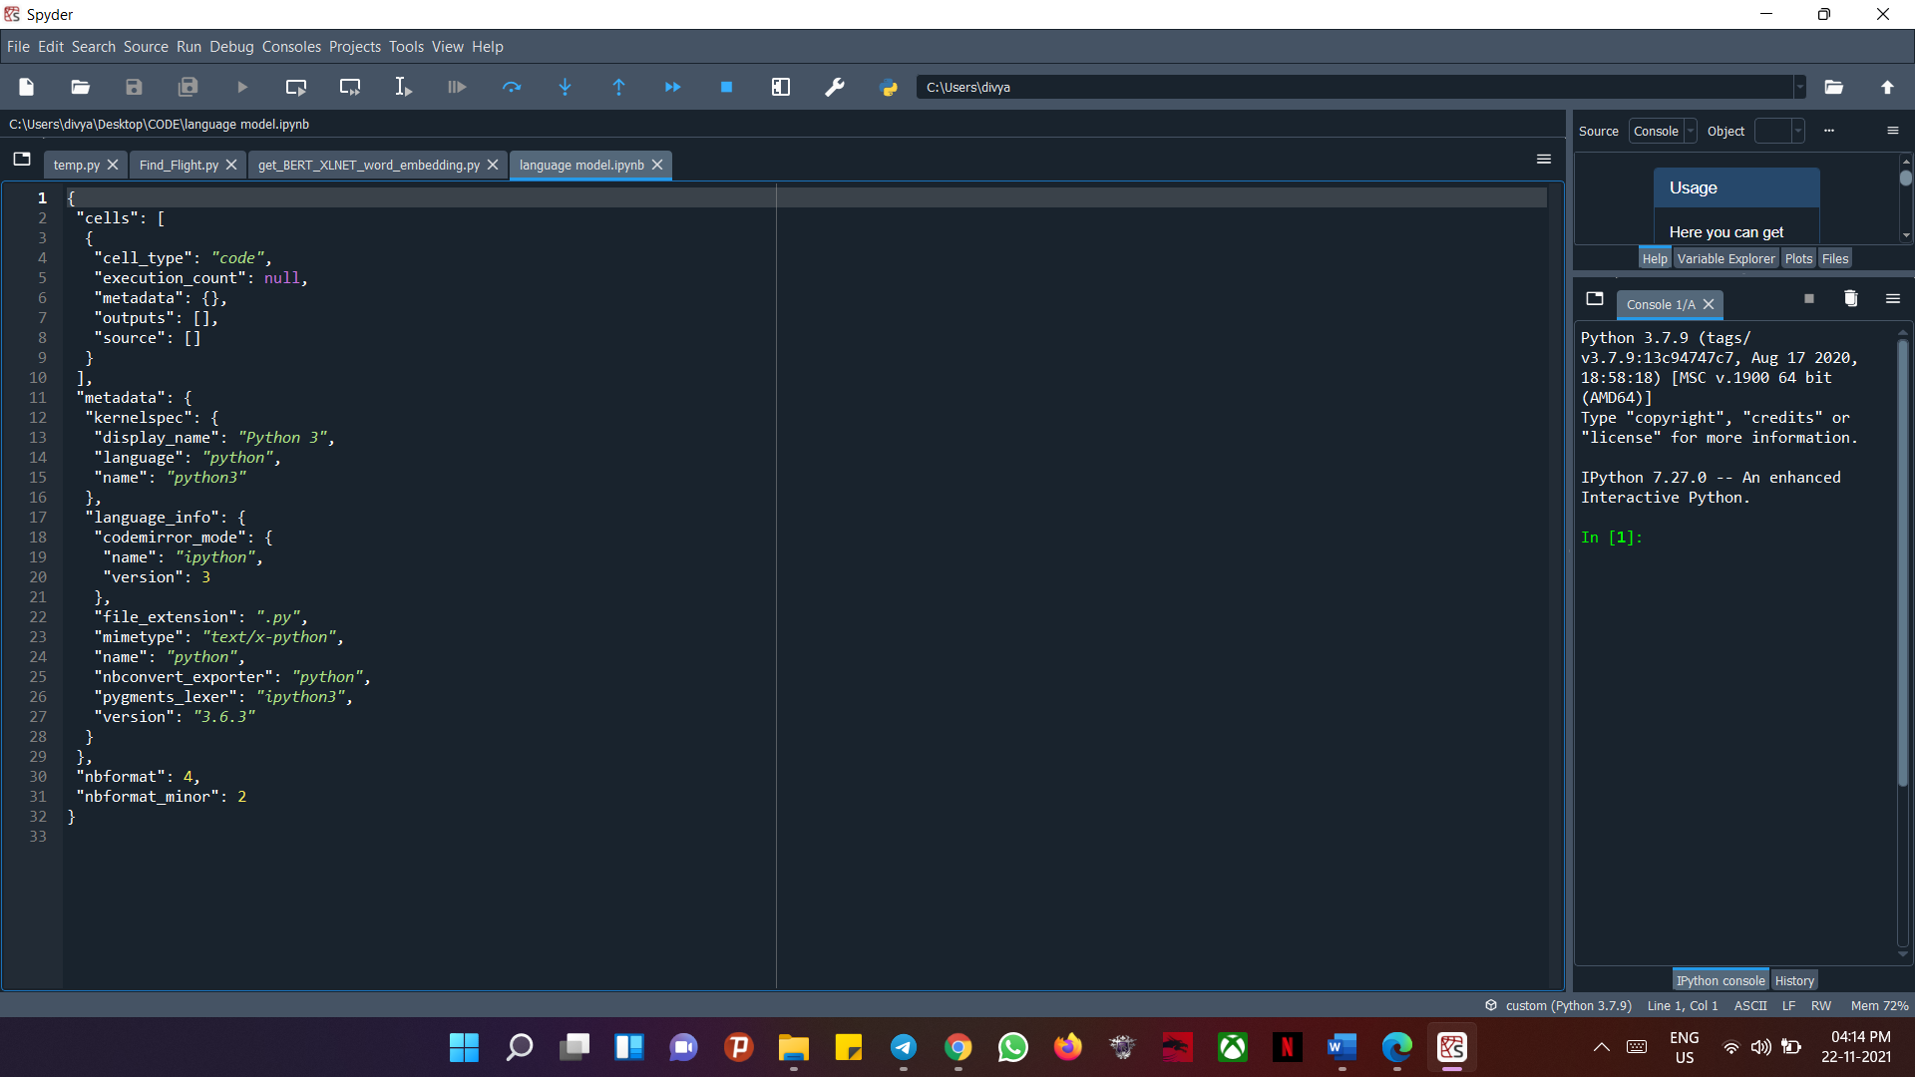

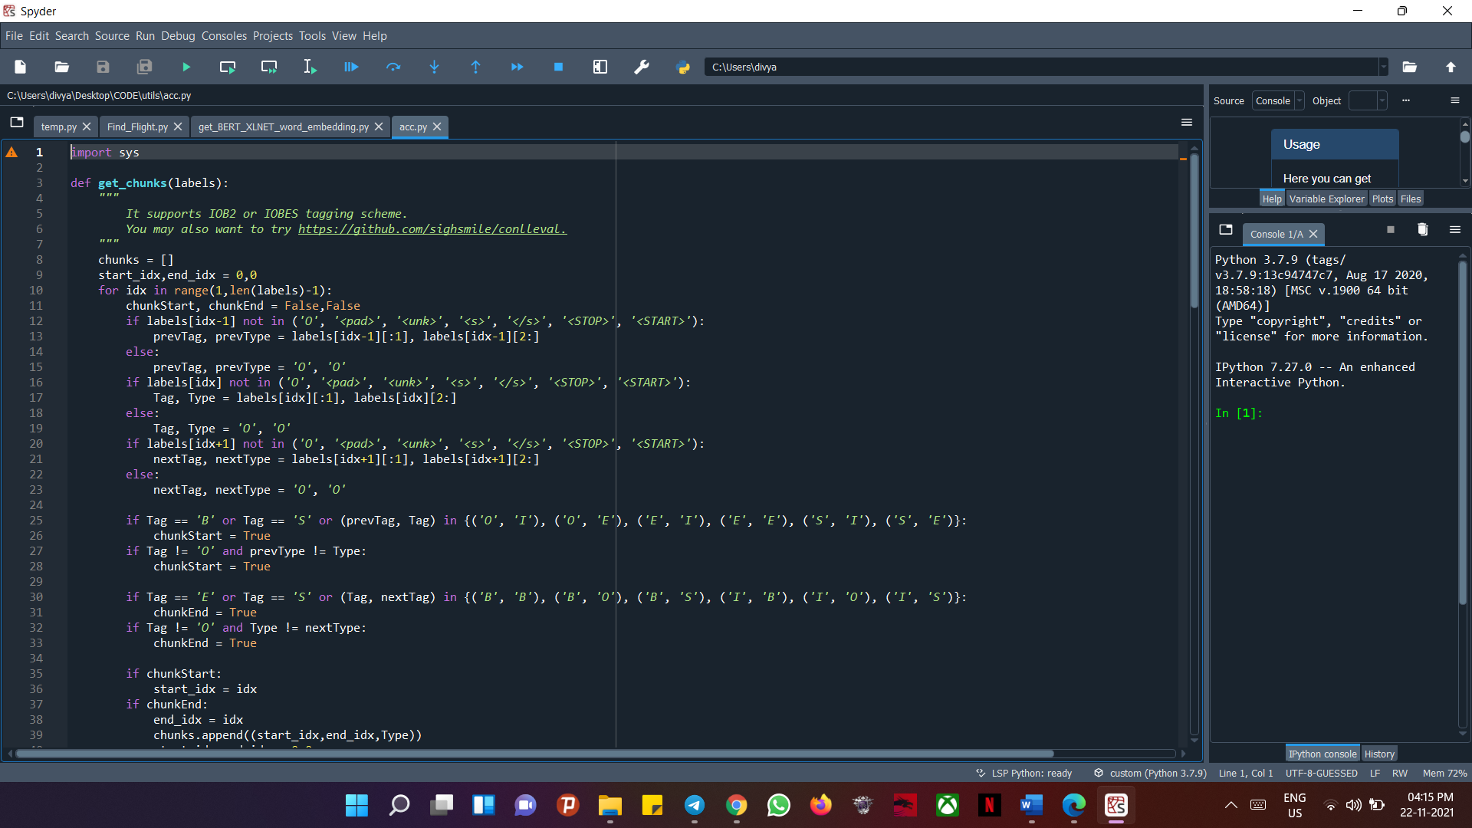

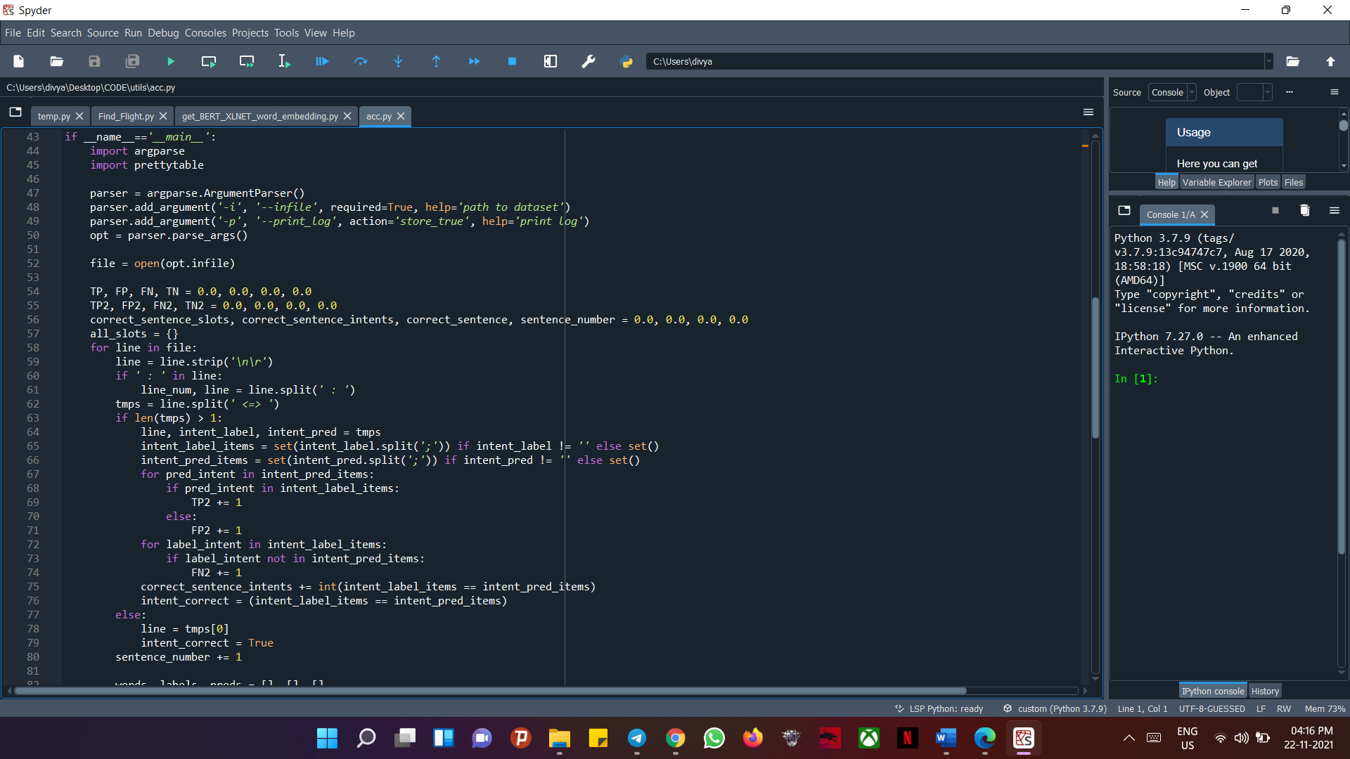

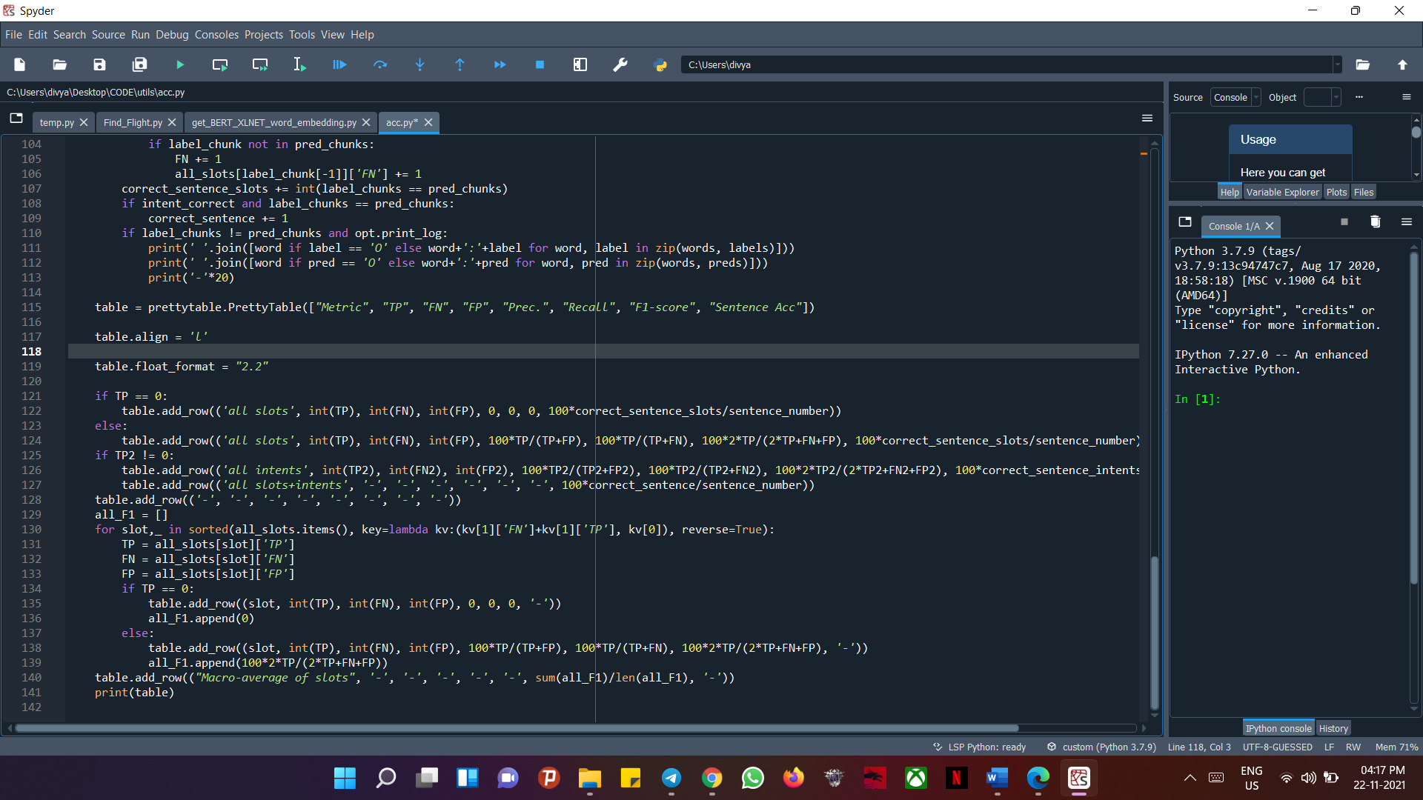

* **Find Flight:**

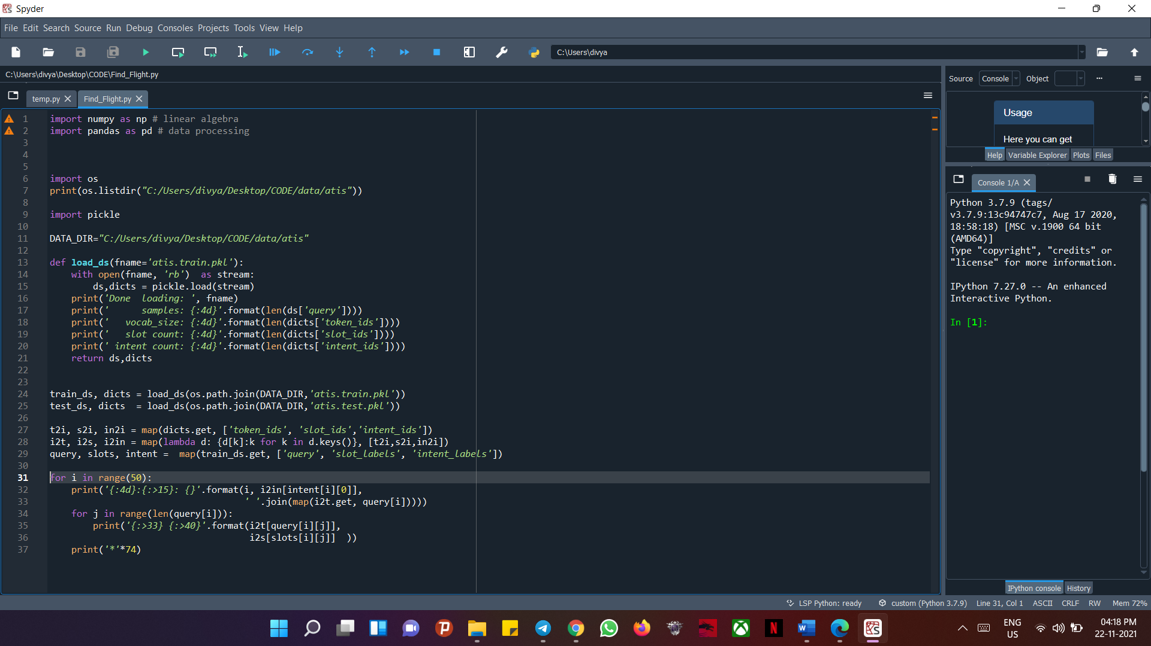

* **Outputs:**

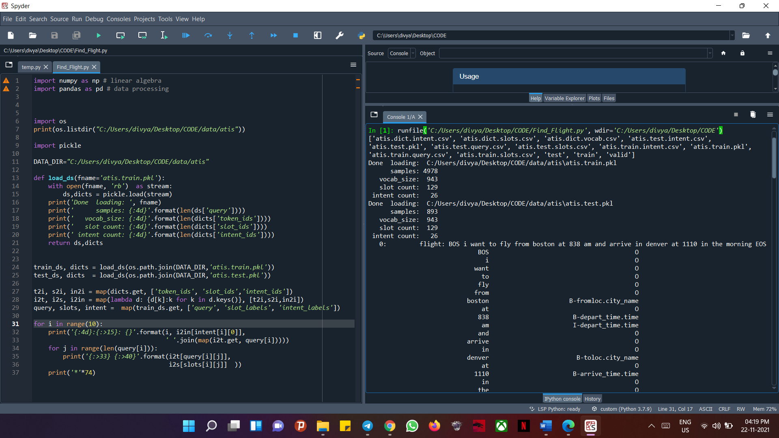

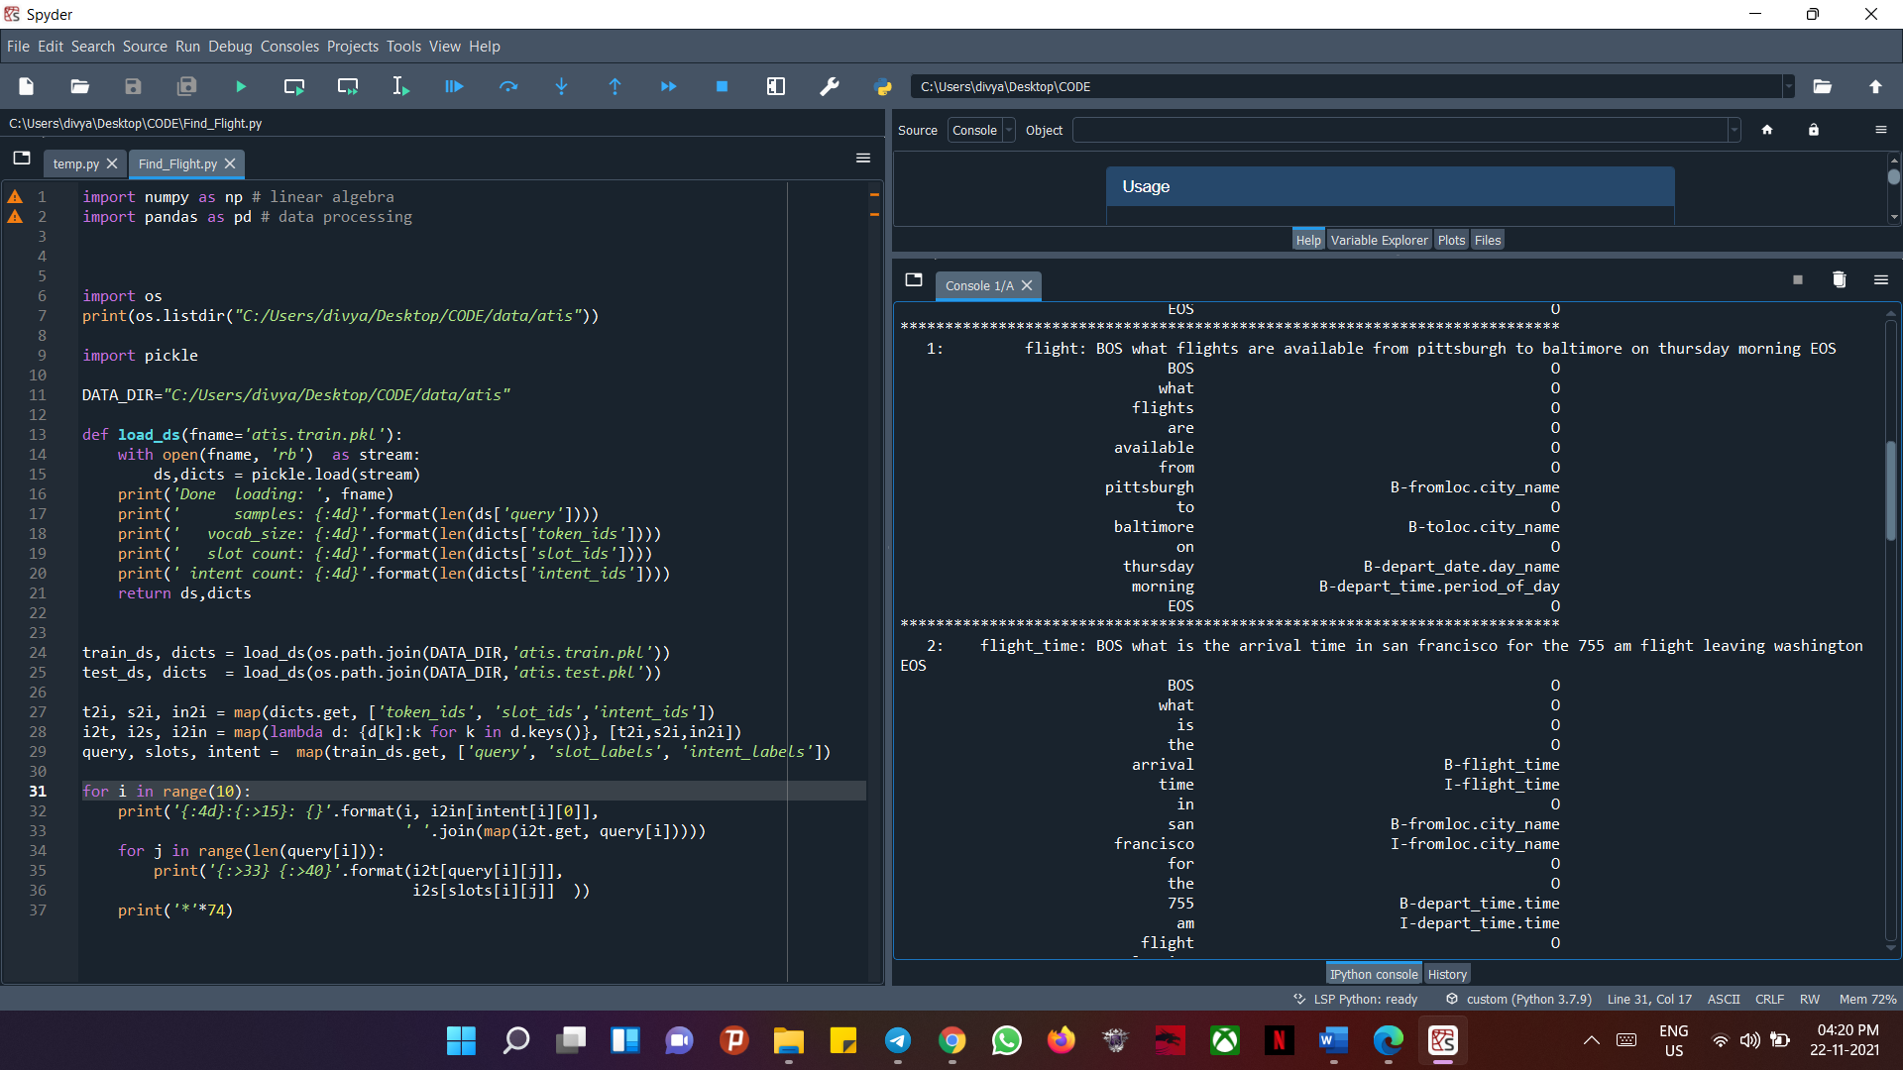

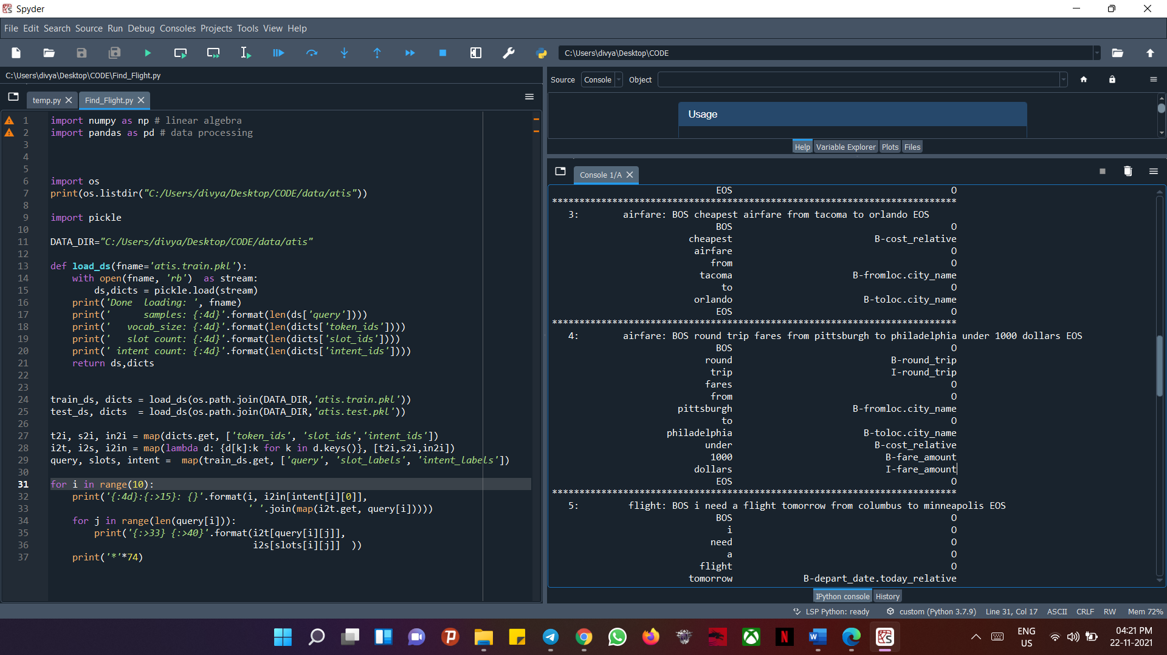

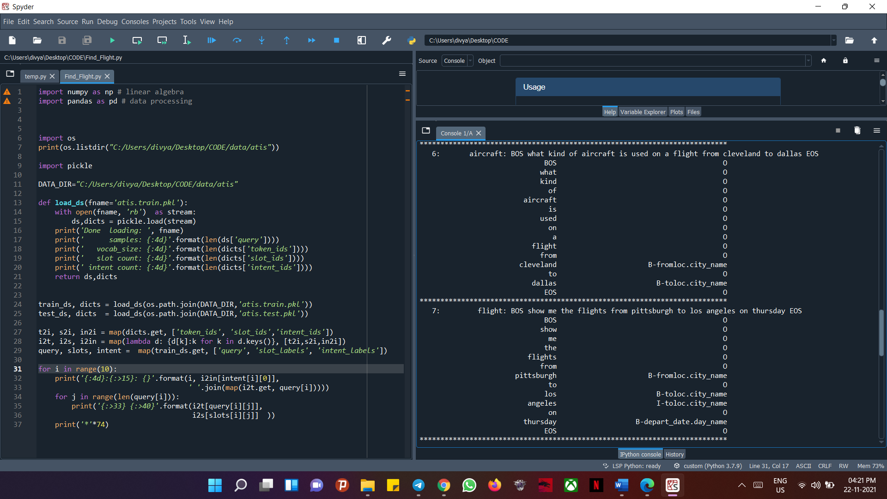

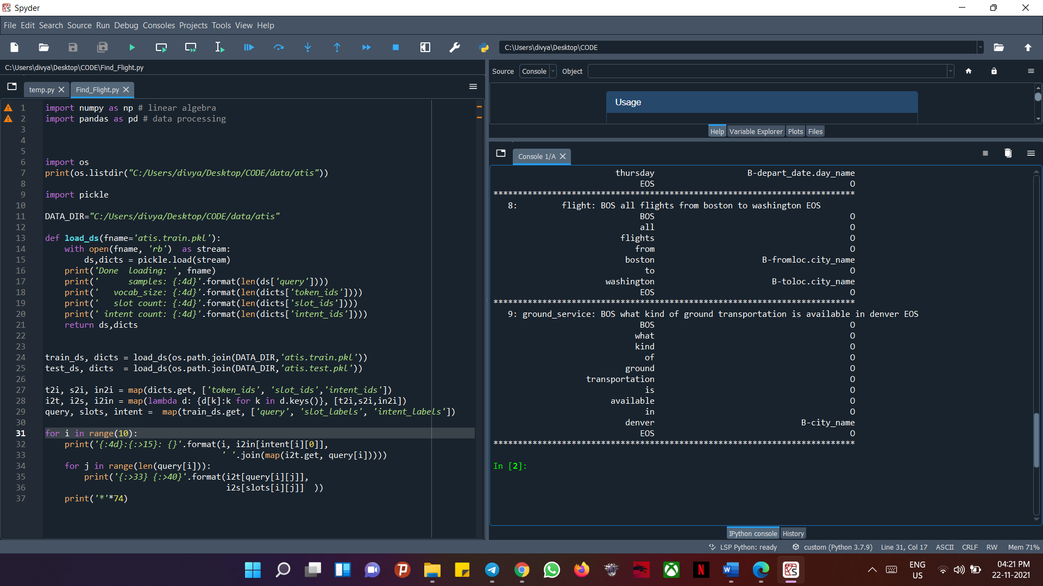

# Chapter 5 CONCLUSION

This paper introduced a novel dual task for SLU: semantic-to-sentence generation (SSG). The usage of unexpressed semantic forms and unlabeled phrases is included in our proposed dual semi-supervised NLU. The dual semi-supervised NLU includes dual pseudo-labeling and dual learning algorithms that can iteratively learn the NLU and SSG models in the primal and dual tasks' closed loops. The suggested approaches are validated using two publicly available datasets (ATIS and SNIPS). According to the results, the dual semi-supervised NLU with SSG may beat traditional semi-supervised techniques significantly. We also conduct extensive ablation research to verify the effectiveness of our techniques. Meanwhile, our techniques can achieve state-of-the-art performance on the two datasets in the supervised context.

The proposed architecture of dual semi-supervised NLU has a lot of room for development in the future.

1. Because semantic forms are well-structured and can be automatically synthesized under domain knowledge, using them for semi-supervised learning may be more cost-efficient and effective than collecting in-domain phrases.
2. Although our suggested methodology is agnostic to the NLU task's backbone model, it will be effective in exploring multiple NLU models and highlighting the bottleneck where dual learning reaches its performance limit.]
3. The proposed dual semi-supervised NLU architecture has a lot of room for development in the future.
4. Because semantic forms are well-structured and can be automatically synthesized under domain knowledge, using them for semi-supervised learning may be more cost-efficient and effective than collecting in-domain phrases. Despite the fact that our suggested framework is independent of the NLU task's backbone model, it will be interesting to investigate multiple NLU models and identify the bottleneck where dual learning reaches its performance limit.

# Chapter 6 REFERENCES

1. **Y.-Y. Wang, L. Deng, and A. Acero**, “Spoken language understanding– an introduction to the statistical framework,” IEEE Signal Processing Magazine, vol. 22, no. 5, pp. 16–31, 2005.
2. **P. Xu and R. Sarikaya**, “Convolutional neural network based triangular CRF for joint intent detection and slot filling,” in Proc. IEEE ASRU, 2013, pp. 78–83.
3. **B. Liu and I. Lane,** “Attention-based recurrent neural network models for joint intent detection and slot filling,” in Proc. INTERSPEECH, 2016, pp. 685–689.
4. **X. Zhang and H. Wang**, “A joint model of intent determination and slot filling for spoken language understanding,” in Proc. IJCAI, 2016, pp. 2993– 2999.
5. **C.-W. Goo, G. Gao, Y.-K. Hsu, C.-L. Huo, T.-C. Chen, K.-W. Hsu, and Y.-N. Chen,** “Slot-gated modeling for joint slot filling and intent prediction,” in Proc. NAACL, 2018, pp. 753–757.
6. **Q. Chen, Z. Zhuo, and W. Wang**, “BERT for joint intent classification and slot filling,” CoRR, vol. abs/1902.10909, 2019. [Online]. Available: <https://arxiv.org/abs/1902.10909>
7. **L. Qin, W. Che, Y. Li, H. Wen, and T. Liu,** “A stack-propagation framework with token-level intent detection for spoken language understanding,” in Proc. EMNLP-IJCNLP, 2019, pp. 2078–2087.

### R. De Mori, F. Bechet, D. Hakkani-Tur, M. McTear, G. Riccardi, and

**G. Tur,** “Spoken language understanding,” IEEE Signal Processing Magazine, vol. 25, no. 3, pp. 50–58, 2008.

1. **G. Tur and L. Deng**, “Intent determination and spoken utterance classification,” Spoken language understanding: systems for extracting semantic information from speech. Wiley, Chichester, pp. 93–118, 2011.

[10] **R. Sarikaya, G. E. Hinton, and A. Deoras,** “Application of deep belief networks for natural language understanding,” IEEE/ACM Trans. On Audio, Speech and Lang. Process., vol. 22, no. 4, pp. 778–784, 2014.

1. **Y.-Y. Wang, L. Deng, and A. Acero,** “Semantic frame-based spoken language understanding,” in Spoken Language Understanding: Systems for Extracting Semantic Information from Speech, Tur and De Mori Eds. New York, NY, USA: Wiley, 2011, ch. 3, pp. 35–80.
2. **Y. He and S. Young**, “A data-driven spoken language understanding system,” in Proc. IEEE ASRU, 2003, pp. 583–588.
3. **C. Raymond and G. Riccardi,** “Generative and discriminative algorithms for spoken language understanding,” in Proc. INTERSPEECH, 2007, pp.1605–1608.
4. **G. Mesnil, Y. Dauphin, K. Yao, Y. Bengio, L. Deng, D. Hakkani- Tur, X. He, L. Heck, G. Tur, D. Yu et al.,** “Using recurrent neural networks for slot filling in spoken language understanding,” IEEE/ACM Trans. Audio, Speech, Lang. Process., vol. 23, no. 3, pp. 530–539, 2015.
5. **K. Yao, B. Peng, Y. Zhang, D. Yu, G. Zweig, and Y. Shi**, “Spoken language understanding using long short-term memory neural networks,” in IEEE SLT Workshop, 2014, pp. 189–194.
6. **N. T. Vu,** “Sequential convolutional neural networks for slot filling in spoken language understanding,” in Proc. INTERSPEECH, 2016, pp. 3250– 3254.
7. **G. Kurata, B. Xiang, B. Zhou, and M. Yu,** “Leveraging sentence-level information with encoder LSTM for semantic slot filling,” in Proc. EMNLP, 2016, pp. 2077–2083.
8. **S. Zhu and K. Yu,** “Encoder-decoder with focus-mechanism for sequence labelling based spoken language understanding,” in Proc. ICASSP, 2017, pp. 5675–5679.
9. **C. Li, L. Li, and J. Qi,** “A self-attentive model with gate mechanism for spoken language understanding,” in Proc. EMNLP, 2018, pp. 3824–3833.
10. **L. S. Zettlemoyer and M. Collins**, “Online learning of relaxed CCG

grammars for parsing to logical form,” in Proc. EMNLP-CoNLL, 2007, pp. 678–687.

1. **G. Tur, D. Hakkani-Tur, and R. E. Schapire**, “Combining active and ̈ semi-supervised learning for spoken language understanding,” Speech Communication, vol. 45, no. 2, pp. 171–186, 2005.
2. **D.-H. Lee**, “Pseudo-label: The simple and efficient semi-supervised learning method for deep neural networks,” in Workshop on challenges in representation learning, ICML, vol. 3, 2013, p. 2.
3. **A. Celikyilmaz, R. Sarikaya, D. Hakkani-Tur, X. Liu, N. Ramesh, and G. Tur,** “A new pre-training method for training deep learning ̈ models with application to spoken language understanding.” in Proc. INTERSPEECH, 2016, pp. 3255–3259.
4. **O. Lan, S. Zhu, and K. Yu,** “Semi-supervised training using adversarial multi-task learning for spoken language understanding,” in Proc. ICASSP, 2018, pp. 6049–6053.
5. **D. He, Y. Xia, T. Qin, L. Wang, N. Yu, T.-Y. Liu, and W.-Y. Ma,** “Dual learning for machine translation,” in Proc. NeurIPS, 2016, pp. 820– 828.
6. **C. T. Hemphill, J. J. Godfrey, G. R. Doddington et al.,** “The atis spoken language systems pilot corpus,” in Proc. the DARPA speech and natural language workshop, 1990, pp. 96–101.
7. **A. Coucke, A. Saade, A. Ball, T. Bluche, A. Caulier, D. Leroy, C. Doumouro, T. Gisselbrecht, F. Caltagirone, T. Lavril, M. Primet, and J. Dureau**, “Snips voice platform: an embedded spoken language understanding system for private-by-design voice interfaces,” CoRR, vol. abs/1805.10190, 2018. [Online]. Available: https://arxiv.org/abs/1805.10190
8. **G. Mesnil, X. He, L. Deng, and Y. Bengio,** “Investigation of recurrent- neural-network architectures and learning methods for spoken language understanding.” in Proc. INTERSPEECH, 2013, pp. 3771–3775.
9. **K. Yao, G. Zweig, M.-Y. Hwang, Y. Shi, and D. Yu,** “Recurrent neural networks for language understanding.” in Proc. INTERSPEECH, 2013, pp.

2524–2528.

1. **N. T. Vu, P. Gupta, H. Adel, and H. Schutze,** “Bi-directional recurrent neural network with ranking loss for spoken language understanding,” in Proc. ICASSP, 2016, pp. 6060–6064.
2. **Y.-N. Chen, D. Z. Hakkani-Tur, and X. He**, “Zero-shot learning of intent embeddings for expansion by convolutional deep structured semantic models,” in Proc. ICASSP, 2016, pp. 6045–6049.
3. **D. Hakkani-Tur, G. Tur, A. Celikyilmaz, Y.-N. Chen, J. Gao, L. Deng, and Y.-Y. Wang**, “Multi-domain joint semantic frame parsing using bi-directional RNN-LSTM,” in Proc. INTERSPEECH, 2016, pp. 715–719.
4. **N. Reimers and I. Gurevych**, “Optimal hyperparameters for deep lstm- networks for sequence labeling tasks,” CoRR, vol. abs/1707.06799, 2017. [Online]. Available: <https://arxiv.org/abs/1707.06799>
5. **F. Zhai, S. Potdar, B. Xiang, and B. Zhou,** “Neural models for sequence chunking.” in Proc. AAAI, 2017, pp. 3365–3371.
6. **C. Zhang, Y. Li, N. Du, W. Fan, and S. Y. Philip,** “Joint slot filling and intent detection via capsule neural networks,” in Proc. ACL, 2019, pp. 5259–5267.